**Chapter 1**

**INTRODUCTION**

**1.1 Definition**

“Data acquisition and prediction for dynamic transport infrastructure planning and simulation”- states the collection of quantitative data of current traffic provided by Google maps and learning the data to estimate the future traffic flow in order to reduce the traffic congestion and increase the country’s economy.

**1.2 Problem Definition**

India is said to be the fastest developing country today only after China. Although India is doing exceptionally well in fields like education, industrialization and fashion there are still certain areas where the country is lagging behind [1].

India's road network is gigantic and said to be only after the United States of America. India has a road network of over 4,689,842 Kilometres (2,914,133 miles) in 2013, the second largest road network in the world. At 0.66 km of roads per square Kilometre of land, the quantitative density of India's road network is similar to that of the United States (0.65) and far higher than that of China (0.16) or Brazil (0.20) [2]. However, qualitatively India's roads are a mix of modern highways and narrow, unpaved roads. But one of the striking underlying facts is the condition of the roads.

Since roads indirectly contribute to the economic growth of the country it is extremely essential that the roads are well laid out and strong. India is the home to several bad roads be it the metropolitans, the cities or the villages. Bad road conditions are nothing new to India and the problem is being addressed since the last 30 years [1].

In India on an average scale an individual spends 1500 hours per year on the road stuck in traffic congestion. Considering the cost of 100 Rupees per hour, with the population of just Bangalore the cost to the state would be approximately 6500 cores [3]. Further, due to the increased density of traffic on roads, accidents, breakdowns and other random events also increase. These incidents further increase the congestion on road of a typical city.

The cities like Bangalore which were not expected to grow so rapidly and did so due to the advent of Information Technology boom have not been planned for such huge traffic population. Majority of the road in such cities across India are unplanned, haphazard and crooked. Further, acquiring lands in the city for infrastructure development is a political concern. Planning roads, fly-over and crawl-under now comes with obligation and obligatory points across the city.

**1.3 Traffic Congestion**

**1.3.1 Definition**

Traffic congestion is a condition on road networks that occurs as use increases, and is characterized by slower speeds, longer trip times, and increased vehicular queuing. When traffic demand is great enough that the interaction between vehicles slows the speed of the traffic stream, it results in some congestion.

As demand approaches the capacity of a road (or of the intersections along the road), extreme traffic congestion sets in. When vehicles are fully stopped for periods of time, this is colloquially known as a traffic jam or traffic snarl-up. Traffic congestion can lead to drivers becoming frustrated and engaging in road rage.

**1.3.2 Problems**

India loses Rs 60,000 crore a year due to congestion (including fuel wastage), slow speed of freight vehicles and waiting time at toll plazas and checking points, a study on operational efficiencies of freight transportation by roads has claimed [3].

The Transport Corporation of India and IIM (Calcutta) study said while India's freight volume was increasing at a compounded annual growth rate of 9.08% and vehicles were growing at 10.76%, the road length was increasing at only 4.01%. This has resulted paucity of road space to accommodate vehicles and to increase the speed.

India has more truly congested cities than any other nation, which is not surprising, since it is also the world's second-most populous country, after China. Vehicles in India are distributed somewhat unevenly. Delhi, Mumbai, Kolkata and Bangalore have 5% of India's population but 14% of its registered vehicles [4]. Traffic is growing four times faster than the population in six cities: Mumbai, Delhi, Ahmedabad, Bangalore, Chennai and Hyderabad [5].

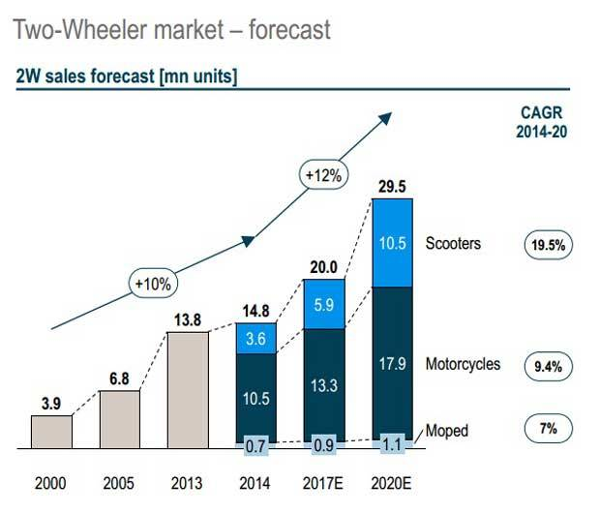

Figure 1.1: Growth in vehicle population

According to the statistics and as shown in Table 1.1 Vehicle population is illogically doubling every year. Road space can never keep pace with the vehicle population.

Reasons for Increase in Number of Vehicles:

1. Increase in population is mainly due to migration and growth of IT and service sectors in Bangalore offering better job opportunities.
2. Inadequate public transport which is unable to meet the demands of the growing population and convenience and comfort of private vehicles and auto-rickshaws. Unpopularity of public transport in case of educational institutions and the trend in hiring cabs by ITeS sector and public has increased the private and intermediate mode of transport.
3. Comfortable cars which are bigger in size which have occupancy of 2 during peak hours have become a status symbol with more people preferring to buy such vehicles.
4. Auto rickshaws which are a popular mode of intermediate transport during peak hours in Bangalore has a vehicle occupancy of only 1.1 adding to the increased volume during peak hour traffic in a large way.
5. Affordability and easy access to financial institutions which have reduced the interest rates on vehicle loans from 15 percentage to 8 to 10 percentage.
6. Increase in the household income and improvement in the standard of living [5].

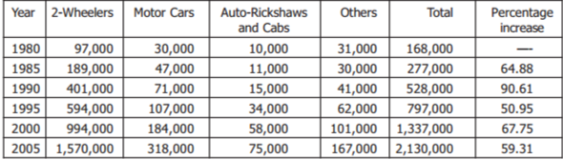

Table 1.1: Bangalore number of motorized vehicle and growth rate. 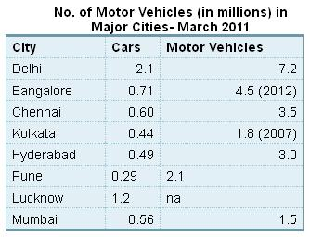

Figure 1.2 Number of Vehicles in different cities of India

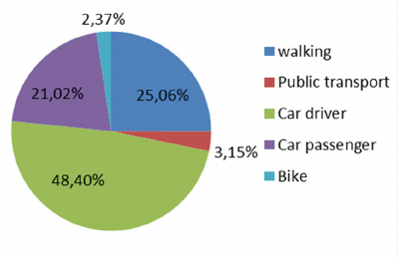

Figure 1.3: Factors that causes the traffic

Traffic congestion occurs when a volume of traffic or modal split generates demand for space greater than the available road capacity; this point is commonly termed saturation.Traffic congestion is a condition on road networks that occurs as use increases, and is characterized by slower speeds, longer trip times, and increased vehicular queuing.

Traffic congestion has a number of negative effects:

1. Wasting time of motorists and passengers ("[opportunity cost](https://en.wikipedia.org/wiki/Opportunity_cost)"). As a non-productive activity for most people, congestion reduces regional economic health.
2. Delays, which may result in late arrival for employment, meetings, and education, resulting in lost business, disciplinary action or other personal losses.
3. Inability to forecast travel time accurately, leading to drivers allocating more time to travel "just in case", and less time on productive activities.
4. Wasted fuel increasing [air pollution](https://en.wikipedia.org/wiki/Air_pollution) and [carbon dioxide emissions](https://en.wikipedia.org/wiki/Greenhouse_gas) owing to increased idling, acceleration and braking.
5. Wear and tear on vehicles as a result of idling in traffic and frequent acceleration and braking, leading to more frequent repairs and replacements.
6. Stressed and frustrated motorists, encouraging [road rage](https://en.wikipedia.org/wiki/Road_rage) and reduced health of motorists.
7. Emergencies: blocked traffic may interfere with the passage of emergency vehicles travelling to their destinations where they are urgently needed.
8. [Spill over effect](https://en.wikipedia.org/wiki/Spillover_effect) from congested main arteries to secondary roads and side streets as alternative routes are attempted (*'*[*rat running*](https://en.wikipedia.org/wiki/Rat_running)*'),* which may affect neighbourhood [amenity](https://en.wikipedia.org/wiki/Amenity) and [real estate](https://en.wikipedia.org/wiki/Real_estate) prices.
9. Higher chance of collisions due to tight spacing and constant stopping-and-going.

**1.3.3 Causes**

Traffic congestion occurs when a volume of traffic or modal split generates demand for space greater than the available road capacity; this point is commonly termed saturation. There are a number of specific circumstances which cause or aggravate congestion, most of them reduce the capacity of a road at a given point or over a certain length, or increase the number of vehicles required for a given volume of people or goods.

Road connectivity network of Bangalore has no consistency in road widths and roads are discontinuous. The arterial roads are intersected by local roads at frequent intervals leading to bottlenecks and congestion. Although the ring roads can take the increased volume of traffic, people tend to use the CBD as thoroughfare, as the ring road is about 8 kilometres away from the city centre. To travel this extra distance is a burden on the public in terms of time and cost.

The number of vehicles on the road is much more than the carrying capacity of the roads leading to congestion, reduced speed and delay in travel time. The other reason for congestion is that Bangalore has buses as the only mode of public transport as the railways contribute to only intercity passenger traffic and cargo traffic and are not aligned to integrate with the city network to carry the intra-city commuters.

Due to lack of adequate parking facilities, on-street parking has reduced the width of the roads, more so in the CBD which has narrow roads. Moreover, spill over of pedestrians on to the road due to ill maintained, inadequate or absence of pavements has increased the congestion on the roads. In the areas such as Kalasipalyam, Tharagupet and other parts of the CBD trucks enter during late night hours and are parked throughout the day on the roads reducing the efficiency of the road for movement of other vehicles and pedestrians.

With industries and residential development moving out to the suburbs due to better amenities and incentives, the segregation of land use has taken place. The CBD, which has concentration of government offices, transport nodes and commercial activities, both wholesale and retail, attracts city dwellers, which has resulted in large number of vehicles moving in and out of the CBD.

Since India is a developing nation there is a constant demand for good quality infrastructure, transportation and services to avoid traffic congestion caused. But since India is a huge country with quite a sizable population this problem still has not been addressed in totality. In the increased need for transportation on land and commutation for various professional, personal and emergency needs, the need for a better civil infrastructure for transportation. The transportation planning plays a crucial role in solving traffic problems. As discussed before majority of the road in cities across India are unplanned, haphazard and crooked. Further, acquiring lands in the city for infrastructure development is a political concern. Planning roads, fly-over and crawl-under now comes with obligation and obligatory points across the city.

Transportation planning software is developed from the 1960’s and is widely used by the planners when the personal computers are widely used. Transportation planning software was a leap in the development of transportation infrastructure. The transportation planning software comes to a new stage when the GIS, Remote sensing, simulation of traffic and other similar technologies are used. The transportation planning software is hardly an indispensable tool for transportation planners. There is hardly any transportation planning project which does not use transportation planning software today.

As mentioned earlier, in the rapidly growing country like India a major hurdle to plan is the survey data. The density of traffic, the environmental conditions, soil conditions, and so on. Further, calculating the deviation ratio with high precision of the traffic from an existing clogged road into newly constructed roads would take its own sweet time for the survey engineers; for this cannot happen overnight. As per the stats, very few software can forecast the traffic demand with the current traffic conditions.

Adjusted for its large population, India has less than 3.8 kilometres of roads per 1000 people, including all its paved and unpaved roads. In terms of quality, all season, 4 or more lane highways, India has less than 0.07 kilometres of highways per 1000 people, as of 2010 [7]. These are some of the lowest road and highway densities in the world.

As the population is increasing disastrously number of vehicles is growing at an average pace of 10.16% per annum over the last five years [6]. The basic problem is not the number of vehicles in the country but their concentration in a few selected cities, particularly in metropolitan cities.

There is a need of comprehensive tool that can forecast, plan, and design considering all the parameters and at hand dynamically change the designs as per requirement in matter of minutes. This will not only facilitate the engineers with the survey but also will provide templates for design scientifically.

We intend to develop a tool which acquires the current traffic data and predict the future traffic data near to accurate to facilitate the engineers with the survey.

**1.4 Summary**

In this chapter statistics regarding transportation management is established. The need for managing and auditing traffic along with its live survey becomes very important and the same has been explained.

**Chapter 2**

**LITERATURE SURVEY**

From the 1960s, hundreds of transportation planning software has been developed. Many of them are widely used. These planning software can be divided into three generations.

1. The first generation is the planning software run on DOS system or Linux system of text mode, which can just be operated by commands and are very difficult to use. The old version of EMME/2 belongs to this kind.

2. The second generation of the planning software is the ones that run on Microsoft windows system or Linux with desktop, which have user-friendly GUI and can be used with graphic GUI.

3. The transportation planning software based on GIS are considered as the third generation. Geographic information systems designed specifically are used to store, display, manage, and analyse transportation data. These kind of transportation planning software combine GIS and transportation modelling capabilities into a single integrated platform, providing capabilities that are unmatched by any other package.

Density, speed, and flow are the three critical parameters for road traffic analysis. High performance road traffic management and control require real-time estimation of space, mean, speed and density as input for large spatial and temporal coverage of the roadway network.

The attributes of the popular transportation planning software are listed in Table 2.1

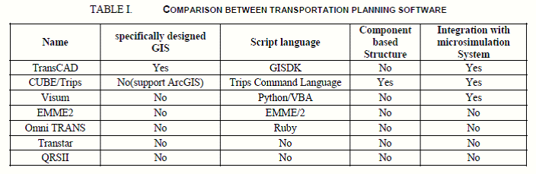

Table 2.1: Comparison between transportation planning software

The widely used transportation planning software all have user-friendly GUI, and more and more transportation planning software support GIS.

**2.1 TransCAD system using GUI:**

TransCAD[8] is the only one with Geographic Information System (GIS) designed specifically for use by transportation professionals to manage transportation data. It is widely used in China, America and other countries around the world today.

Most of popular planning software can be easily extended by scripting language or macro script. Vissum and Omni use python and ruby which is widely used today. TransCAD, CUBE and Vissum are well integrated with micro simulation system. TransCAD can obtain traffic data from GPS. Few of them are designed based on component architecture, because most of them are designed decays ago or are updated from the old version.

"TransCAD 6.0” released on November 1, 2012:

TransCAD combines GIS and transportation modelling capabilities in a single integrated platform, providing capabilities that are unmatched by any other package. TransCAD can be used for all modes of transportation, at any scale or level of detail. TransCAD provides:

1. A powerful GIS engine with special extensions for transportation

2. Mapping, visualization, and analysis tools designed for transportation applications

3. Application modules for routing, travel demand forecasting, public transit, logistics, site location, and territory management

TransCAD has applications for all types of transportation data and for all modes of transportation, and is ideal for building transportation information and decision support systems. TransCAD runs on readily-available hardware under Microsoft Windows and embraces virtually all desktop computing standards. This has two important benefits:

1. You can acquire and install TransCAD at a much lower cost than any other integrated GIS and transportation modelling solution.

2. You don’t have to build custom applications or complicated data interchange modules to perform transportation analysis with GIS data.

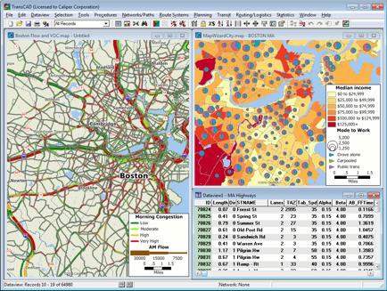

Figure 2.1: TransCAD system using GUI

**2.2 Adaptive traffic control system:**

The Adaptive Traffic Control System (ATCS)[9] is a personal computer based traffic signal control program which provides fully responsive traffic signal control based on real-time traffic conditions. ATCS automatically adjusts traffic signal timing in response to current traffic demands. ATCS is similar to the Urban Traffic Control System (UTCS) but goes beyond the limitations of UTCS to provide a traffic adaptive system of control. This is done by allowing ATCS to simultaneously control all three critical components of traffic signal timing, namely cycle length, phase split and offset. Adaptive Traffic Control System receives information from vehicle such as position and speed and then it is utilized to optimize the traffic signal. The system specifies the use of on-board sensors in vehicle and standard wireless communication protocol specified for vehicular applications as shown in Figure 2.2

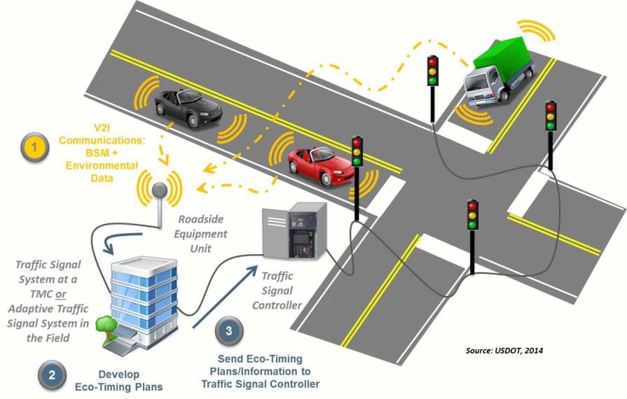

Figure 2.2: Standard wireless communication protocol specified for vehicular applications

**2.3 An Intelligent Secure Traffic Management System Based On Vanet**

Intelligent traffic system for VANET suggests creation for smart city framework for VANET consisting of Intelligent Traffic Lights which transmit warning messages and traffic statistic. In that system various Routing Protocol has been discussed and compared. They suggest that AODB is best suited for Intelligent Traffic Light[5]. Author suggests in reference [6] the data forecasting model for transmitting data from one to other. This article studied about the dynamic traffic control system and based on radio propagation model for predicting path loss and link.

The author suggests in reference [10] Intelligence road Traffic signalling system. In that system OBUs are used. OBUs used destination information for calculating load traffic on road for reducing the conjunction on road. The general belief is that it is more difficult to estimate and predict traffic density than traffic flow. The VANET architecture provides an excellent framework to develop an advanced road traffic signalling system. First formulate the vehicular traffic signal control problem as a job scheduling problem on processors, with jobs corresponding to platoons of vehicles. Under the assumption that all jobs are equal size, by using an online algorithm, which referred to as the oldest job first (OJF) algorithm, to minimize the delay across the intersection.

The OJF algorithm is 2-competitive, implying that the delay is less than or equal to twice the delay of an optimal offline schedule with perfect knowledge of the arrivals .It show that, how a VANET is used to group vehicles into approximately equal-sized platoons, which can then be scheduled using OJF .The two-phase approach are used, where first approach is to group the vehicular traffic into platoons and then apply the OJF algorithm, i.e., the oldest arrival first (OAF) algorithm. Our simulation(NS2) results shows that, under light and medium traffic loads, the OAF algorithm reduce the delay experienced by vehicles as they pass through the intersection, as compared with vehicle-actuated methods, Webster’s method, and pre-timed signal control methods. Under heavy vehicular traffic load, the OAF algorithm performs the same as the vehicle actuated traffic method but still produces the lowest delay, as when compared with Webster’s method and the pre-timed signal control method.

**2.3.1 VANET definition:**

A Vehicular Ad-Hoc Network, or VANET, is a form of Mobile ad-hoc network, to provide communications among nearby vehicles and between vehicles and nearby fixed equipment, usually described as roadside equipment. The main goal of VANET is providing safety and comfort for passengers. To this end a special electronic device will be placed inside each vehicle which will provide Ad-Hoc Network connectivity for the passengers.

This network tends to operate without any infra-structure or legacy client and server communication. Each vehicle equipped with VANET device will be a node in the Ad-Hoc network and can receive and relay others messages through the wireless network.

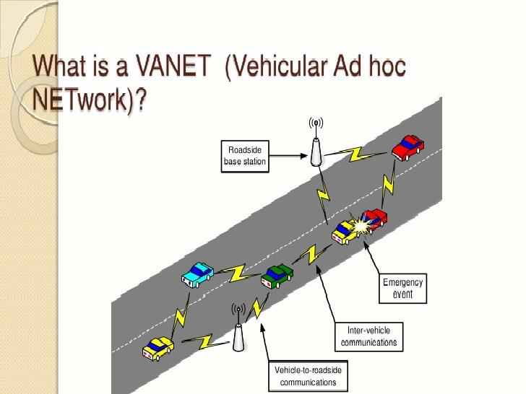

Figure 2.3: VANET

Collision warning, road sign alarms and in place traffic view will give the driver essential tools to decide the best path along the way. Vehicular Ad Hoc Networks (VANET) are a form of MANETs used for communication among vehicles and between vehicles and roadside equipment shown in Figure 2.3

**2.4 Priority based traffic lights controller using wireless sensors**

Priority Based Traffic Lights Controller Using Wireless Sensor Network [11], the author implements Adaptive Traffic control System based on (WSN) wireless sensor network. In that system, time manipulation is used for controlling traffic light. This system control traffic over multiple intersections. As such, it is becoming very crucial to device efficient, adaptive and cost-effective traffic control algorithms that facilitate and guarantee fast and smooth traffic flow that utilize new and versatile technologies. An excellent potential candidate to aid on achieving this objective is the Wireless Sensor Network (WSN). Many studies suggested the use of WSN technology for traffic control. In, a dynamic vehicle detection method and a signal control algorithm to control the state of the signal light in a road intersection using the WSN technology were proposed. In the that project, two junctions are discussed and brought into focus along with the use of wireless sensors as many studies suggest the use of sensors. If there is no traffic lights control system in these junctions, huge amount of traffic causes waiting time and accidents. As a result, physical existence of traffic police is always required there which is inappropriate due to availability of technology today. Also, due to heavy traffic in these two junctions, emergency vehicles face hardships when they pass from there. Sensors will be located at a specific distance before the junctions which will detect the speed and sound waves of siren at a particular threshold. Based on the speed, sensors will communicate wirelessly with the traffic control system of the two junctions while realizing their routes. On the basis of WSN traffic control systems of the two junctions will be able to minimize the traffic flow by inter communication thus assigning the right time for red and green lights so that emergency vehicles can pass quickly. A WSN is used as a tool to instrument and control traffic signals roadways, while an intelligent traffic controller is developed to control the operation of the traffic infrastructure supported by the WSN. Simulation results show the efficiency of the proposed scheme in solving traffic congestion in terms of the average waiting time and average queue length on the isolated (single) intersection and efficient global traffic flow control on multiple intersections.

**2.5 Density Based Intelligent Traffic Signal System Using PIC Microcontroller**

In this project, optimization of traffic light controller in a City using microcontroller done. The system tries to reduce possibilities of traffic jams, caused by traffic lights, to an extent. The microcontroller used in the system is PIC. The system contains IR transmitter and IR receiver which are mounted on the either sides of roads respectively. The IR system gets activated whenever any vehicle passes on road between IR transmitter and IR receiver. Microcontroller controls the IR system and counts number of vehicles passing on road. Microcontroller also store vehicles count in its memory. Based on different vehicles count, the microcontroller takes decision and updates the traffic light delays as a result. The traffic light is situated at a certain distance from the IR system. Thus based on vehicle count, microcontroller defines different ranges for traffic light delays and updates those accordingly. The system records vehicle count in its memory at user predefined recording interval on real time basis. This recorded vehicle count data can be used in future to analyse traffic condition at respective traffic lights connected to the system. For appropriate analysis, the recorded data can be down-loaded to the computer through communication between microcontroller and the computer. Thus administrator on a central station computer can access traffic conditions on any approachable traffic lights and nearby roads to reduce traffic congestions to an extent. In future this system can be used to inform people about different places traffic condition.

**2.6 Previous Work**

Easy Infra -1 initially was started for five junctions namely : Axatech Junction, Hosur Road 1, Hosur Road 2, Ring Road and Silk Board junctions.

The project was carried out on JAVA for automation and OpenCV for image processing.

The data was collected for three weeks upon which the prediction was done. The GUI for end-user was to be prepared. It also required a web hosting service to be activated.

In the version 2 of **Easy Infra**, the numbers of junctions were increased from 5 to 113 thus covering the most of Bengaluru.

PHP was chosen for automation and image processing both, as PHP is lighter than JAVA and OPENCV put together.

The GUI for end-user application is done using PHP for backend processing along with Google Maps APIs and HTML for frontend.

**2.7 Summary**

This chapter talks about the different generations of transportation planning software, popular transportation planning software and the approaches used for the same.

**Chapter 3**

**SOFTWARE REQUIREMENT SPECIFCATION**

**3.1 Requirements**

**3.1.1 Integrating maps with markers for predefined geo-locations**

* 1. Maps for pre-defined geo-locations on HTML.

The Google Maps API (getCurrentPosition ()) is used to get the predefined position on the map using latitude and longitude values.

* 1. Apply markers for each of the geo-locations.  
     We add markers for the user to locate the particular pre-defined junction. The marker position is automatically updated as the user position changes.
  2. Automate the whole process of applying markers.

Writing a script to automate the process of applying markers on the map.

**3.1.2Extending the number of junctions across Bengaluru**

* 1. Saving the latitude-longitude of major junctions with names across Bengaluru North in a CSV file.
  2. Saving the latitude-longitude of major junctions with names across Bengaluru East in a CSV file.
  3. Saving the latitude-longitude of major junctions with names across Bengaluru West in a CSV file.
  4. Saving the latitude-longitude of major junctions with names across Bengaluru South in a CSV file.
  5. Saving the latitude-longitude of major junctions with names across Bengaluru Central in a CSV file.
  6. Integrating 2.i to 2.v into a single CSV file.

**3.1.3 Click functionality data acquisition on the marker**

* 1. On click, pop up for static data.

When the user clicks on the marker, a pop up window with a

Graph is displayed to the user that indicates the traffic density of that particular junction.

* 1. Automate on click pop up for all the junctions defined in objective 2.

Same as objective 2.3.i but for multiple junctions.

* 1. Implementing dynamic data  
     It shows the present traffic density.

**3.1.4 Prediction of the data on map**

* 1. Date picker on the pop up box.

Allows the user to select a date which he wants the traffic to be predicted.

* 1. Traffic prediction on the date clicked.

Prediction of the traffic density of the date selected by the user.

**3.1.5 Autocomplete:**

The Autocomplete widget provides suggestions while user types in the field. Here the suggestions are locations, Example: Typing "Ma" gives list as Marathalli and Madivala. Upon selection of the location, the map is centred to that location on user interface.

**3.2 Algorithm for traffic pattern analysis for Bengaluru traffic**

Analyse the traffic pattern on the streets to identify high, medium and low density traffic zones.

The major junctions in Bangalore where traffic is abundant are selected and the Lat-Long of those junctions are stored in a file.

* Map for the Lat-Long positions is constructed.
* Wait until the map is loaded into the headless browser.
* Taking snapshot of the loaded map of every pre-defined junction, which is stored in a  
  database. The image is saved in PNG format.
* Then the image is fetched from the database and the colour (RGY) is converted into its equivalent numeric value. The numeric values are used for calculating the traffic percentage.
* The numeric values obtained is stored in the database; the values are compared with each other.
* If the value of red is greater than green and yellow, then the traffic density is displayed as high. If the value of yellow is greater than green and red, then the traffic density is displayed as moderate. If the value of green is greater than red and yellow, then the traffic density is displayed as low.
* The process of taking snapshots, getting numeric values and percentage calculation is done continuously for at least two weeks. Then we predict the traffic density on any given day of the week on the basis of the data collected from the previous two weeks.
* We then compare the predicted traffic with the actual value to see if there is any deviation in the value. The difference in actual and predicted values is computed simultaneously.

**3.3 Solutions for traffic related problems**

* 1. Alternative paths.

Finding the alternative path from source to destination to divert or reduce the traffic.

* 1. Infrastructural solution.

Building subways, bridges and flyovers can reduce the traffic.

* 1. Providing data for Advertising agencies.

High traffic areas, makes the commuters to stop before proceeding. During such periods, the advertising agencies can provide with advertisements so that the number of viewers do increase.

* 1. **Software Requirements**
* Google Maps
* Phantom JS
* PHP
* MySQL
* Markers
* Google JavaScript API’s
* Date Picker
* Cloud
* FileZilla and SSH

**3.4.1 Google Maps**

Google Maps is a desktop web mapping service developed by Google. It offers satellite imagery, street maps, 360° panoramic views of streets (Street View), real-time traffic conditions (Google Traffic), and route planning for traveling by foot, car, bicycle (in beta), or public transportation.



Figure 3.1 Google Maps

**3.4.2 Markers**

A marker identifies a location on a map. Markers can display custom images, in which case they are usually referred to as "icons." Markers and icons are objects of type Marker.

  
Figure 3.2 Markers

**3.4.3 PhantomJS**

PhantomJS is an open source, scripted, headless browser used for automating web page interaction. PhantomJS provides a JavaScript API enabling automated navigation, screenshots, user behaviour and assertions making it a common tool used to run browser-based unit tests in a headless system like a continuous integration environment. PhantomJS is based on web kit making it a similar browsing environment to Safari and Google Chrome.



Figure 3.3 Phantom JS

**3.4.4 PHP**

PHP (recursive acronym for *PHP: Hypertext Pre-processor*) is a widely-used open source general-purpose scripting language that is especially suited for web development and can be embedded into HTML. PHP is not limited to creating just HTML output. It can also be used to create and manipulate image files in a variety of different image formats, including GIF, PNG, JPEG, WBMP, and XPM. Even more conveniently, PHP can output image streams directly to a browser. You will need to compile PHP with the GD library of image functions for this to work. GD and PHP may also require other libraries, depending on which image formats you want to work with. PHP is chosen as an alternative for OpenCV for image processing and automation as OpenCV is a huge library of functions and overloads the server when used along with JAVA for automation.



Figure 3.4 PHP

**3.4.5 MYSQL**

MySQL is a powerful database. It's very good and free of charge. Many developers in the world selected MySQL and PHP for developing their website.   
The MySQL database has become the world's most popular open source database because of its consistent fast performance, high reliability and ease of use. It's used in more than 6 million installations ranging from large corporations to specialized embedded applications on every continent in the world.   
 Not only is MySQL the world's most popular open source database, it's also become the database of choice for a new generation of applications built on the LAMP stack (Linux, Apache, MySQL, PHP / Perl / Python.) MySQL runs on more than 20 platforms including Linux, Windows, OS/X, HP-UX, AIX, Netware, giving you the kind of flexibility that puts you in control.

MySQL is used for data dumping into database and also forms the heart of our Prediction Engine.



Figure 3.5 MySQL

**3.4.6 Google JavaScript API’s**

The Google Maps JavaScript API is a powerful, popular mapping API. It's simple to use to add maps to your website, or web or mobile application, and provides a wide range of services and utilities for data visualization, map manipulation, directions, and more.  


Figure 3.5 JavaScript

**3.4.7 Date Picker**

A date picker, popup calendar, date and time picker, or time picker is a graphical user interface widget which allows the user to select a date from a calendar and/or time from a time range.

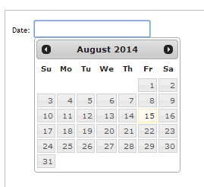

Figure 3.7 Date Picker

**3.4.8 Cloud**

Cloud computing, often referred to as simply “the cloud,” is the delivery of on-demand computing resources—everything from applications to data centres—over the Internet on a pay-for-use basis.



Figure 3.8 Google Cloud

**3.4.9 FileZilla and SSH**

FileZilla is powerful and free software for transferring files over the Internet. FileZilla is a very popular FTP client and is used by webmasters from all over the world. In this tutorial we will show how to manage your web site files through FileZilla.

FileZilla is free software, cross-platform FTP application, consisting of FileZilla Client and FileZilla Server. Client binaries are available for Windows, Linux, and macOS, server binaries are available for Windows only.

The client supports FTP, SFTP and FTPS. FileZilla's source code is hosted on SourceForge and the project was featured as Project of the Month in November 2003.However, there have been criticisms that SourceForge bundles malicious software with the application; and that FileZilla stores users' FTP passwords insecurely.



Figure 3.9 FileZilla

Secure Shell (SSH) is a cryptographic network protocol for operating network services securely over an unsecured network. The best known example application is for remote login to computer systems by users.

SSH provides a secure channel over an unsecured network in a client-server architecture, connecting an SSH client application with an SSH server. Common applications include remote command-line login and remote command execution, but any network service can be secured with SSH. The protocol specification distinguishes between two major versions, referred to as SSH-1 and SSH-2.The most visible application of the protocol is for access to shell accounts on Unix-like operating systems, but it sees some limited use on Windows as well. In 2015, Microsoft announced that they would include native support for SSH in a future release.

SSH was designed as a replacement for Telnet and for unsecured remote shell protocols such as the Berkeley rlogin, rsh, and rexec protocols. Those protocols send information, notably passwords, in plaintext, rendering them susceptible to interception and disclosure using packet analysis. The encryption used by SSH is intended to provide confidentiality and integrity of data over an unsecured network, such as the Internet, although files leaked by Edward Snowden indicate that the National Security Agency can sometimes decrypt SSH, allowing them to read the contents of SSH sessions

**3.5 Functional Requirements applications in our project**

**3.5.1 Google Maps**

Google Maps is the base of our project. It is used to locate the geo-locations of our selected area of interest, Bengaluru. The Google Maps traffic layer is required to understand the density of traffic of the area of interest of the user.

**3.5.2 Phantom JS**

Phantom JS, a headless web kit, used to capture the image of Google Maps automatically at regular intervals of time.

**3.5.3 PHP**

Once the image is captured by Phantom JS, we use PHP to process it and red, yellow and green filters are applied so that we can calculate the traffic density.

**3.5.4 Markers**  
 Markers are used to indicate the junction on the maps to be selected by the user.

**3.5.5 Google Maps JavaScript API’s**

Google Maps JavaScript API’s are used to get Google maps canvas, apply markers on to the predefined locations.

**3.5.6 Date Picker**

Date Picker is embedded in the pop up in Google Maps. It is used by user to pick the date when he wants the date to be predicted. The traffic is predicted for the date the user clicks and its density is thus displayed on the popup.

**3.5.7 Cloud**

Cloud is used to store the data collected during image capturing by Phantom JS, and the processed images from the server using PHP.

**3.6 Non-Functional Requirements**

**3.6.1 Accuracy**

The degree to which the result of a measurement, calculation, or specification conforms to the correct value or a standard.

**3.6.2 Performance**

Performance is most often represented in storage products by two statistics finding and accessing the blocks of data out from storage systems**.**

**3.6.3 Look and Feel**

In this part we mainly focus on the user interface, i.e., the web page is dynamic and responds to user interaction.

**3.6.4 Consistency**

Consistency in database systems refers to the requirement that any given database transaction must change affected data only in allowed ways. The usefulness and overall accuracy of a map is closely related to the consistency of application of mapping unit definitions to the landscape.

**3.6.5 Modular Design**

Modular design is a design approach that subdivides a system into smaller parts called modules that can be independently created and then used in different systems. Any change in code should not affect other code, the data must be mutually exclusive.

**3.6.7 Simplicity**

Software deployment is all of the activities that make a software system available for use. The general deployment process consists of several interrelated activities with possible transitions between them. These activities can occur at the producer side or at the consumer side or both.

**3.7 Hardware Requirements**

**3.7.1 Server**

To run the code for analysing the current traffic condition and predicting the traffic for the date picked by the user:   
The server configurations:

|  |  |
| --- | --- |
| RAM | 8GB |
| OS | Linux – Ubuntu 14.04 |
| Hard Drive | 10GB |
| CPUs | 2 |

**3.8 Use Cases**

|  |  |  |  |  |
| --- | --- | --- | --- | --- |
| Use Case ID: 01 | | Use Case Name: User Logging into our website | | Reference Use Case ID: NIL |
| Requirement(s) Explored: 3.1.1, 3.1.2 | | | | |
| **Actor(s):** User | | | | |
| **Preconditions:** | | | | |
| **Main Course of Action:** Once user logs into the website, the grid of all the pre-defined junctions along with markers on the Google map is viewed to the user. | | | | |
|  | | | | |
| **Use Case ID:** 02 | | **Use Case Name:** Maps for pre-defined geo-location | | **Reference Use Case ID:** NIL | | |
| **Requirement(s) Explored:** 3.1.1 | | | | | | |
| **Actor(s):** Browser | | | | | | |
| **Preconditions:**  Internet connection | | | | | | |
| **Main Course of Action:** Search for directions for several modes of transportation, including transit, driving, walking or cycling. Used as the canvas in the project to locate the geo-locations. Using the traffic layer, we analyse the present traffic density. | | | | | | |

|  |  |  |
| --- | --- | --- |
| **Use Case ID:** 03 | **Use Case Name:** Apply markers for each of the geo-locations | **Reference Use Case ID:** NIL |
| **Requirement(s) Explored:** 3.1.1 | | |
| **Actor(s):** User | | |
| **Preconditions:**  To be inserted on the particular junction on the map | | |
| **Main Course of Action:** Markers help in indicating the junctions that are predefined on a map. | | |

|  |  |  |
| --- | --- | --- |
| **Use Case ID:** 04 | **Use Case Name:** Automate the whole process of applying markers | **Reference Use Case ID:** NIL |
| **Requirement(s) Explored:** 3.1.1 | | |
| **Actor(s):** Server, Browser | | |
| **Preconditions:**  Internet connection | | |
| **Main Course of Action:** The automatic updating of traffic density for all the pre-defined junctions is done | | |

|  |  |  |
| --- | --- | --- |
| Use Case ID: 05 | Use Case Name: Saving latitude-longitude of major junctions | Reference Use Case ID: NIL |
| Requirement(s) Explored: 3.1.2 | | |
| **Actor(s):** Excel Sheet, Google Maps | | |
| **Preconditions:** A set of pre-defined junctions. | | |
| **Main Course of Action:** The latitude and longitudinal values of the pre-defined junctions are to be identified and stored in a CSV file. | | |

|  |  |  |
| --- | --- | --- |
| Use Case ID: 06 | Use Case Name: Integrating the latitude and longitudes discovered into a single excel sheet | Reference Use Case ID: 04 |
| Requirement(s) Explored: 3.1.2 | | |
| **Actor(s):** Excel Sheet | | |
| **Preconditions:** Excel sheets containing the latitudes and longitudes of pre-defined junctions | | |
| **Main Course of Action:** The latitude and longitudinal values of the pre-defined junctions are that are stored in an excel sheet are merged into a single document. | | |

|  |  |  |
| --- | --- | --- |
| Use Case ID: 07 | Use Case Name: User clicks onto a particular pre-defined junction | Reference Use Case ID: 01 |
| Requirement(s) Explored: 3.1.3 | | |
| **Actor(s):** User | | |
| **Preconditions:** The traffic density of the pre-defined junctions to be calculated | | |
| **Main Course of Action:** When a user clicks on any particular junction, a pop up menu comes up showing the percentage of traffic density at that particular time. | | |

|  |  |  |
| --- | --- | --- |
| Use Case ID: 08 | Use Case Name: User selects particular date from date picker for given location | Reference Use Case ID: 01, 02 |
| Requirement(s) Explored: 3.1.4 | | |
| **Actor(s):** User | | |
| **Preconditions:** Date picker to be inserted in the pop up. | | |
| **Main Course of Action:** When a user selects a particular date, the traffic density at the selected location the traffic density is calculated and displayed. | | |

|  |  |  |
| --- | --- | --- |
| **Use Case ID:** 09 | **Use Case Name:** Traffic data analysis | **Reference Use Case ID:** NIL |
| **Requirement(s) Explored:** 3.1.4 | | |
| **Actor(s):** Server, Browser, CSV file | | |
| **Preconditions:**  Internet connection | | |
| **Main Course of Action:** The future traffic density is calculated based on the past traffic density available in the excel sheet and also stored in one another excel sheet. | | |

|  |  |  |
| --- | --- | --- |
| **Use Case ID:** 10 | **Use Case Name:** Display of the Traffic Density analysed | **Reference Use Case ID:** 14 |
| **Requirement(s) Explored:** 3.1.3, 3.1.4 | | |
| **Actor(s):** Server, Browser, CSV file, Pop up | | |
| **Preconditions:**  Internet connection | | |
| **Main Course of Action:** The traffic density that has been calculated is displayed on the pop up when user asks for it. | | |

|  |  |  |
| --- | --- | --- |
| **Use Case ID:** 11 | **Use Case Name:** Selection for Area for Graph and Value | **Reference Use Case ID:** NIL |
| **Requirement(s) Explored:** 3.1.3, 3.1.4 | | |
| **Actor(s):** Server, Browser, Pop Up | | |
| **Preconditions:**  Internet connection | | |
| **Main Course of Action:** User selects either of the buttons i.e. Traffic Density value or Graph. Based on the user’s requirement, value or graph is displayed. | | |

|  |  |  |
| --- | --- | --- |
| **Use Case ID:** 12 | **Use Case Name:** Displaying value of traffic density of the location selected | **Reference Use Case ID:** NIL |
| **Requirement(s) Explored:** 3.1.3, 3.1.4 | | |
| **Actor(s):** Server, Browser, CSV file | | |
| **Preconditions:**  Internet connection | | |
| **Main Course of Action:** The traffic density v/s time is displayed on the pop up box | | |

|  |  |  |
| --- | --- | --- |
| **Use Case ID:** 13 | **Use Case Name:** Traffic Pattern, Analysed | **Reference Use Case ID:** NIL |
| **Requirement(s) Explored:** 3.1.5 | | |
| **Actor(s):** Server, Browser | | |
| **Preconditions:**  Internet connection | | |
| **Main Course of Action:** The Traffic pattern predicted for the future date is analysed for the pattern of traffic that transits from a junction to its neighbouring junctions. | | |

|  |  |  |
| --- | --- | --- |
| **Use Case ID:** 14 | **Use Case Name:** Display of the traffic pattern | **Reference Use Case ID:** 09 |
| **Requirement(s) Explored:** 3.1.5 | | |
| **Actor(s):** Server, Browser | | |
| **Preconditions:**  Internet connection | | |
| **Main Course of Action:** The traffic pattern predicted from the junction clicked by the user to its neighbouring junctions is displayed on the maps. | | |

**Chapter 4**

**SYSTEM DESIGN**

The proposed software system can be realized into 3 modules as below.

1. Data Acquisition Unit

2. Data Quantization Unit

3. Prediction Engine

Data Quantization

Data Acquisition

Prediction Engine

Figure 4.1: Modules of the software

**4.1 Data Acquisition**

This is the sense organ of the entire software system. Data the required for the entire processing is obtained in this unit. Google map provides the traffic density of a given road at any given point of time. This is a real time unit, responsible for collecting the traffic data provided by the traffic layer of the Google maps. The snapshots of the junctions under observation are taken periodically and stored for further processing.

A headless browser named PhantomJS pings the traffic layer of the Google maps periodically and the snapshots are captured. This is a data critical software in which the snapshots of the traffic layer plays an important role.

**4.1.1 takeIt.sh**

We calculate the percentage of traffic density by considering the images retrieved from Google maps using PhantomJS as shown in Figure 5.2.

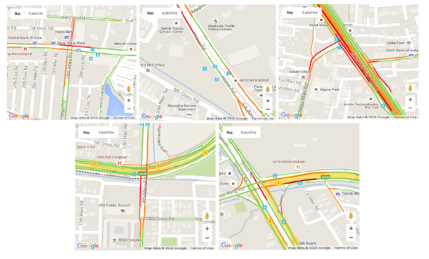

Figure 4.2: Snapshot taken at 5 (axatech, hosur-road, electronic-city, ringroad, silkboard) junctions

In above snapshots (Figure 4.2), red line represents high density traffic, yellow line represents moderate and green line represents low density traffic. Images are taken for every one minute in all the junctions considered.

To get these snapshots, the code snapshot.js is run which includes map.html which accepts latitude and longitude of the junctions to be considered.

**4.2 Data Quantization**

The Data obtained by the previous unit is the image data. Reverse engineering is followed to obtain the quantitative data. The snapshots obtained contain colours that distinguish between the traffic densities. Red represent heavy traffic density, Green represent low traffic density.

The filter algorithm provided by the PHP is applied on to the snapshots. These images are further processed to obtain the quantitative data out of it, by using pixel count method. Percentage of the density values are calculated and stored for further processing.

**4.2.1 Percentage Calculation**

Snapshots are given as an input for percentage calculation. We take RGB value count for quantization and then we calculate total pixel count.

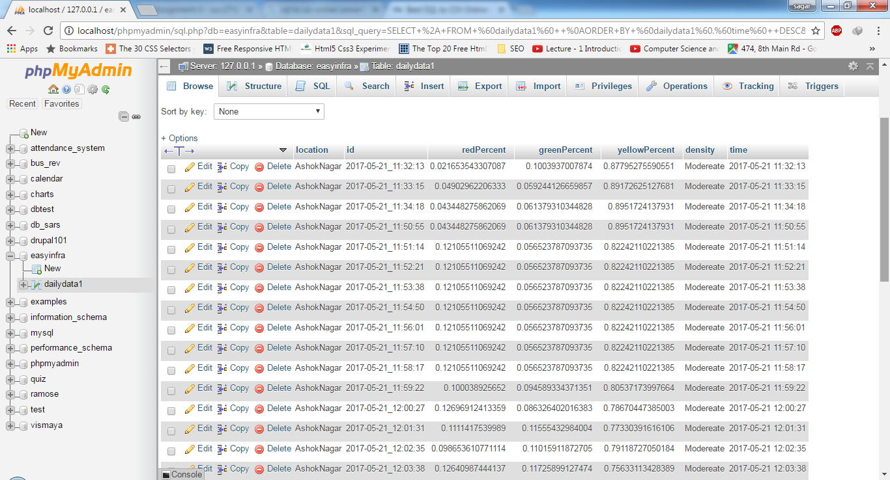

Figure 4.3 Percentage of Red, Green and Yellow pixels calculation

**4.3 Prediction Engine**

Prediction Engine is responsible for forecasting few years ahead of the current traffic conditions. This unit clearly operates on the data that is provided by the previous two units discussed. The same is followed for all the days on which the snaps were captured.

**4.4 Summary**

This chapter talks about the system design of the application. Brief explanation of the modules that comprises the application and its working is given.

**Chapter 5**

**METHODOLOGY**

**5.1 Algorithms**

**5.1.1 Algorithm 1 - Getting snapshots of junctions provided by Google maps**

Step 1: Start.

Step 2: Fetch the Lat-Long from the pre-built data base.

Step 3: Construct a map canvas around the Lat-Long.

Step 4: Call the headless browser to navigate to the constructed map canvas.

Step 5: Wait until the map is loaded into the headless browser.

Step 6: Take a snap shot of the loaded map.

Step 7: The snap shot is taken for every junction which is in PNG format.

Step 8: Repeat Step 3 through step 7 for every min.

**5.1.2 Algorithm 2 - Find the RGY pixels of the snapshots taken**

Step 1: Start

Step 2: Fetch the image.

Step3: Convert the colour (red, green, yellow) in the snapshots to its corresponding numeric value.

Step 4: Three values for each RGY is obtained and stored in the database.

Step 5: These numeric values are given as input for percentage calculation.

Step 6: Repeat Step 2 through Step 5 until all snapshots are fetched from database.

**5.1.3 Algorithm 3 - Quantifying the data (percentage calculation)**

Step 1: Start

Step 2: Numeric values of a particular snapshot are given as input for percentage calculation.

Step 3: Numeric values of RGY is compared to find the traffic density.

Step 4: If the red value is greater than green and yellow then the traffic density is displayed as high, similarly for yellow and green to display moderate and low traffic density.

Step 5: Percentage values are stored in database.

Step 6: Stop.

**5.1.4 Algorithm 4 - The Prediction Engine**

Step 1: Start

Step 2: The percentage values obtained for one full day of a junction is stored in the database.

Step 3: Step 2 is performed for every day of the week for at least 2 weeks

Step 4: The average of all the weeks for a day in week with least deviation is considered for the prediction

Step 5: The predicted data is evaluated with the actual data

Step 6: Repeat the Step2 through Step5 until a desired level of accuracy is achieved

**5.1.5 Algorithm 5 - The Display Engine**

Step 1: Start

Step 2: Obtain the Date and Location from the Date-Picker

Step 3: Make a PHP request to predict the traffic density for the requested date and location

Step 6: Step2 and Step3 are repeated for a variety of inputs.

**5.1.6 Algorithm 6 - The AutoComplete Engine**

Step 1: Check if the user entered Location exists in database

Step 2: If exists, fetch the Lat-Long of the Location entered.

Step 3: Move the map canvas to the location the user has selected.

Step 4: Repeat Step 2 and Step 3 for any user entered location.

**5.2 Code Description**

**5.2.1 Server Side - Cloud**

**7.2.1.1 Code 1**

**Name: image.sh**

**Description:** image.sh is shell script that internally uses takeIt.sh at every folder created for all predefined junctions and creates png files of all the locations and places it in its respective folder.

**5.2.1.2 Code 2**

**Name: compute.php**

**Description:** compute.php uses php-gd image processing library to calculate the red, green and yellow pixels of images and stores it in database.

**5.2.2 Client Side – Hosting server:**

**URL: http://www.easyinfra.esy.es/**

**5.2.2.1 Code 1**

**Name: index.php**

**Description:** index.php is used to present the user interface to the end user. It requires latLong.csv to generate the markers for all the predefined locations. Each marker has a date-picker which helps the user select the date for which he needs to predict traffic.

**5.2.2.2 Code 2**

**Name: prediction.php**

**Description:** prediction.php is the prediction engine of our project. It uses the previously generated data to predict the traffic. It also has error calculation mechanisms too.

**5.3 Summary**

In this chapter, the algorithms used and brief explanation of the content of the codes is discussed.

**Chapter 6**

**TESTING**

For our project, we have considered major 113 junctions:

**6.1 List of junctions:**

|  |  |  |  |  |  |  |  |  |  |  |  |  |  |  |  |  |  |  |  |  |  |  |  |  |  |  |  |  |  |  |  |  |  |  |  |  |  |  |  |  |  |  |  |  |  |  |  |  |  |  |  |  |  |  |  |  |  |  |  |  |  |  |  |  |  |  |  |  |  |  |  |  |  |  |  |  |  |  |  |  |  |  |  |  |  |  |  |  |  |  |  |  |
| --- | --- | --- | --- | --- | --- | --- | --- | --- | --- | --- | --- | --- | --- | --- | --- | --- | --- | --- | --- | --- | --- | --- | --- | --- | --- | --- | --- | --- | --- | --- | --- | --- | --- | --- | --- | --- | --- | --- | --- | --- | --- | --- | --- | --- | --- | --- | --- | --- | --- | --- | --- | --- | --- | --- | --- | --- | --- | --- | --- | --- | --- | --- | --- | --- | --- | --- | --- | --- | --- | --- | --- | --- | --- | --- | --- | --- | --- | --- | --- | --- | --- | --- | --- | --- | --- | --- | --- | --- | --- | --- | --- | --- |
| |  | | --- | | Ashok Nagar | | Banashankari | | Banaswadi | | Bannerghatta Road | | Basaveshwara nagar | | Bel Road | | Bellandur | | Bennigana Halli | | Bidadi | | Bommanahalli | | Brigade Road | | Brookefield | | BTM Layout | | Byatarayanapura | | C.V. Raman Nagar | | Chamarajpet | | Dasarahalli | | Devanahalli | | Dickenson Road | | Doddakallasandra | | Domlur Layout | | Dooravani Nagar | | Electronics City | | Frazer Town | | Gandhi Nagar | | Ganga Nagar | | Gavipuram | | Hanumanthanagar | | Hebbal | | Hennur | | |  | | --- | | Hesaraghatta | | Hosur Road | | HRBR Layout | | HSR Layout | | Indira Nagar | | ITPL Road | | J. P. Nagar | | Jalahalli | | Jaya Nagar | | Jayachamaraja Road | | Jayamahal Road | | Jeevan Bheema Nagar | | Kadugodi | | Kadugondanahalli | | Kalasipalyam | | Kalyan Nagar | | Kammanahalli | | Kasturba Road | | Kasturi Nagar | | Kathriguppe | | Kempe Gowda Road | | Kengeri | | Kodihalli | | Konanakunte | | Koramangala | | Krishnaraja Puram | | Kumaraswamy Layout | | Langford Town | | Lingarajapuram | | Madivala | | |  | | --- | | Magrath Road | | Mahadevapura | | Mahalakshmipuram | | Mahatma Gandhi Road | | Malleshwaram | | Marathahalli | | Maruthi Nagar | | Mathikere | | Mission Road | | Museum Road | | Mysore Road | | Nagarathpet | | Nagarbhavi | | Nagasandra | | Nagashetty Halli | | Nagavara | | Nandhini Layout | | O.T.C. Road | | Old Airport Road | | Padmanabhanagar | | Palya | | Peenya | | Raj Bhavan Road | | Raja Rajeshwari Nagar | | Raja Ram Mohan Roy Road | | Ramamurthy Nagar | | Residency Road | | Sadashiva Nagar | | Sahakara Nagar | | Sampangiram Nagar | |
| |  | | --- | | Sanjay Nagar | | Sankey Road | | Sarjapur Road | | Seshadripuram | | Shanti Nagar | | St. Mark's Road | | St. Thomas Town | | Subramanyapura | | |  | | --- | | Thippasandra | | Tumkur Road | | Ulsoor | | Uttarahalli | | Vaiyyalikaval | | Varthur | | Vidyaranyapura | | Vijay Nagar | | |  |  | | --- | --- | | Vimanapura | | | Vivek Nagar | | | VV Puram | | Whitefield | | Wilson Garden | | Yelahanka | | Yeshwanthpur | |

**6.2 Unit Testing**

**6.2.1. map.html**

a) Map defines a client-side image-map. An image-map is an image with clickable areas. The required name attribute of the map element is associated with the image of a pre-defined latitude and longitude of particular junction.

**6.2.2. .js**

a) An object-oriented computer programming language commonly used to create interactive effects within web browsers.

b) The Date object is a data type built into the JavaScript language. Date objects are created with the new Date( ) .

c) Once a Date object is created, a number of methods allow you to operate on it. Most methods simply allow you to get and set the year, month, day, hour, minute, second, and millisecond fields of the object, using either local time or UTC (universal, or GMT) time.

**6.2.3. shell script**

a) It is a text file that contains a sequence of commands for a UNIX-based operating system

b) It contains single file a sequence of commands that would process the system from a keyboard one at a time.

c) Shell script is used to set the time limit to fetch the images and it also calls snapshot.js to capture the image of a junction.

**6.2.4.php**

a) PHP is a server-side scripting language designed primarily for web development but also used as a general-purpose programming language.

b) Here it is used to fetch RGB value from the snapshot obtained from a pre-defined junctions using lat long.

**6.3 Integration Testing**

Integration testing is a software development process in which program units are combined and tested as groups in multiple ways. In this context, a unit is defined as the smallest testable part of an application.

Big Bang Integration Testing approach is followed in our project. The way this integration testing type works is, most or all of the modules are integrated together to form nearly a complete system. This is very similar to system testing as this basically has a whole system before starting the testing. All the units of the program are integrated and tested. The various units that are integrated and tested include map files, php files, JavaScript files and shell script.

* Map defines a client-side image-map. An image-map is an image with clickable areas. The required name attribute of the map element is associated with the image of a pre-defined latitude and longitude of particular junction.

* On the map - There is an auto-completion of the pre-defined geo-location.(113 locations)

* snapshot is taken using PhantomJS. This snapshot.js is executed using shell script.

* The Date object is a data-type built into the JavaScript language. Date objects are created with the new Date( ) .which is the format of (yyyy-mm-dd).

* Once a Date object is created, a number of methods allow you to operate on it. Most methods simply allow you to get and set the year, month, day, hour, minute, second, and millisecond fields of the object, using either local time or UTC (universal, or GMT) time.

* An object-oriented computer programming language commonly used to create interactive effects within web browsers.

* Shell Script is used to execute both map.html and snapshot.js program.

* It is used to set the time limit to fetch the images and it also calls snapshot.js to capture the image of a junction

* Here the time limit is set to 59th second.

* We use PHP to fetch RGB value from the snapshot obtained from a pre-defined junctions

**6.4 Summary**

In this chapter, we understand the requirements for testing our software. We understand the type of testing we do along with testing methodologies of each module of the project.

**Chapter 7**

**ANALYSIS**

**7.1 Date picker**

Date picker functionality is provided to the user, so that the user can select a date and time, which predicts the traffic density of that particular location.

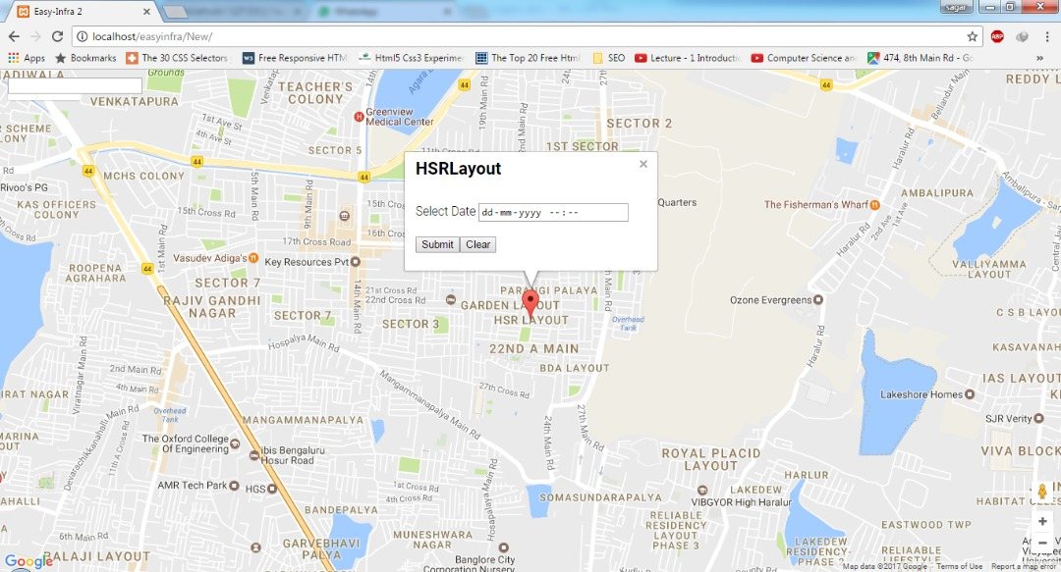

Figure 7.1 Date Picker

**7.2 Autocomplete**

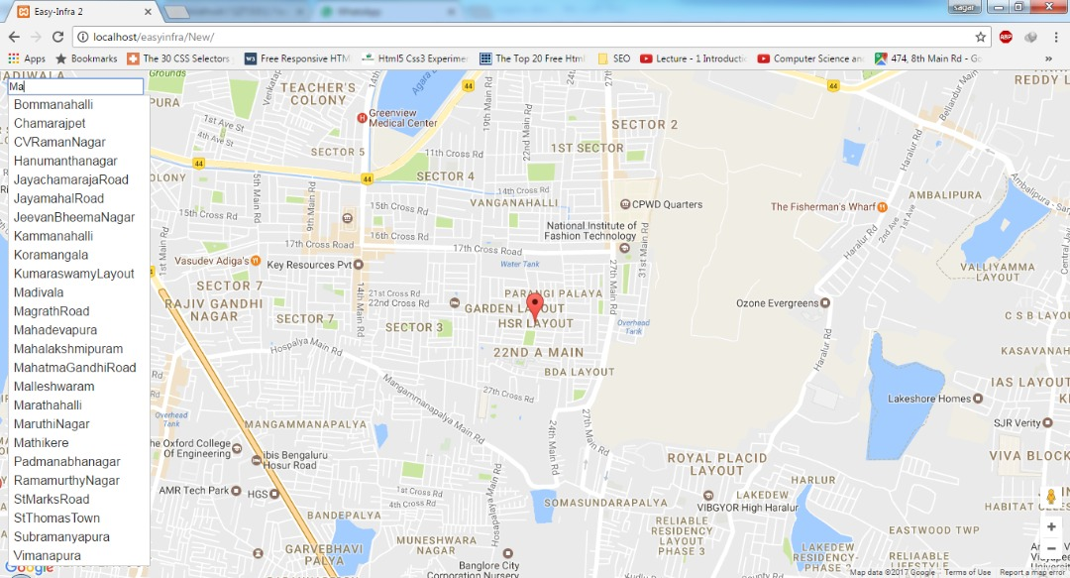The Autocomplete widget provides suggestions while user types in the field. Here the suggestions are locations, Example: Typing "Ma" gives list as Marathalli and Madivala.

Figure 7.2 Autocomplete

**7.3 Prediction**

Predicting the traffic density using previously collected data for the user selected location (one of 113 junctions) date and time. And also to display the error rate.

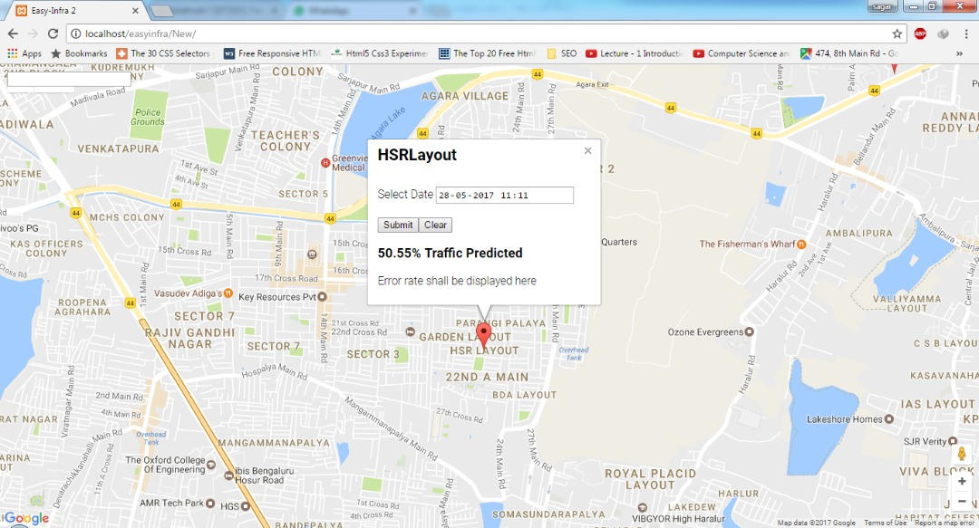

Figure 7.3 Prediction

**7.3 Cloud Computing**

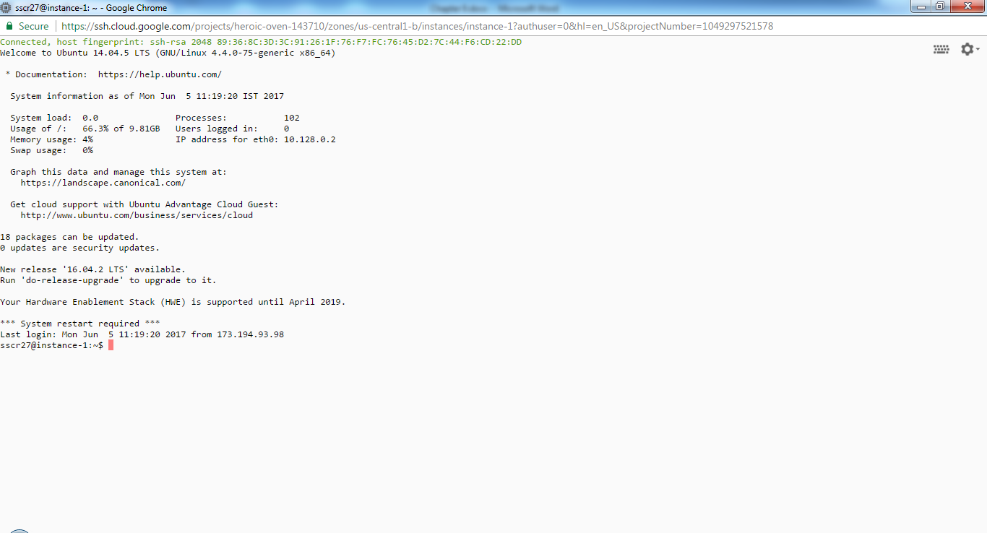

Figure 7.4 Cloud

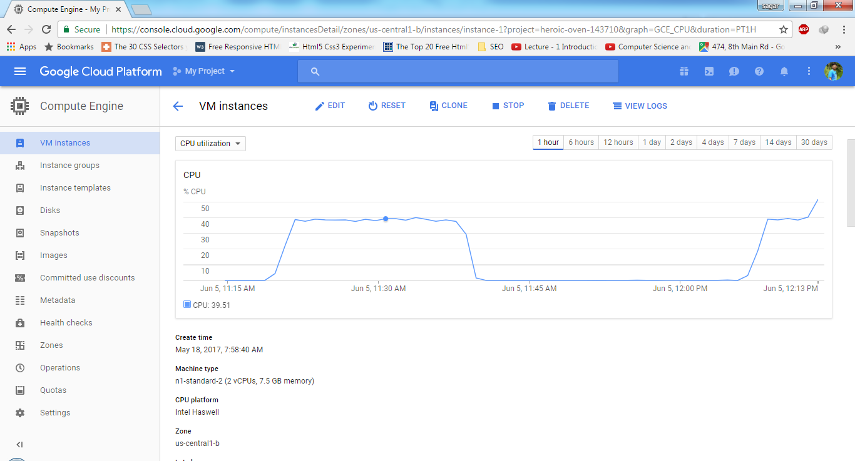

Figure 7.5 Google Cloud Configuration

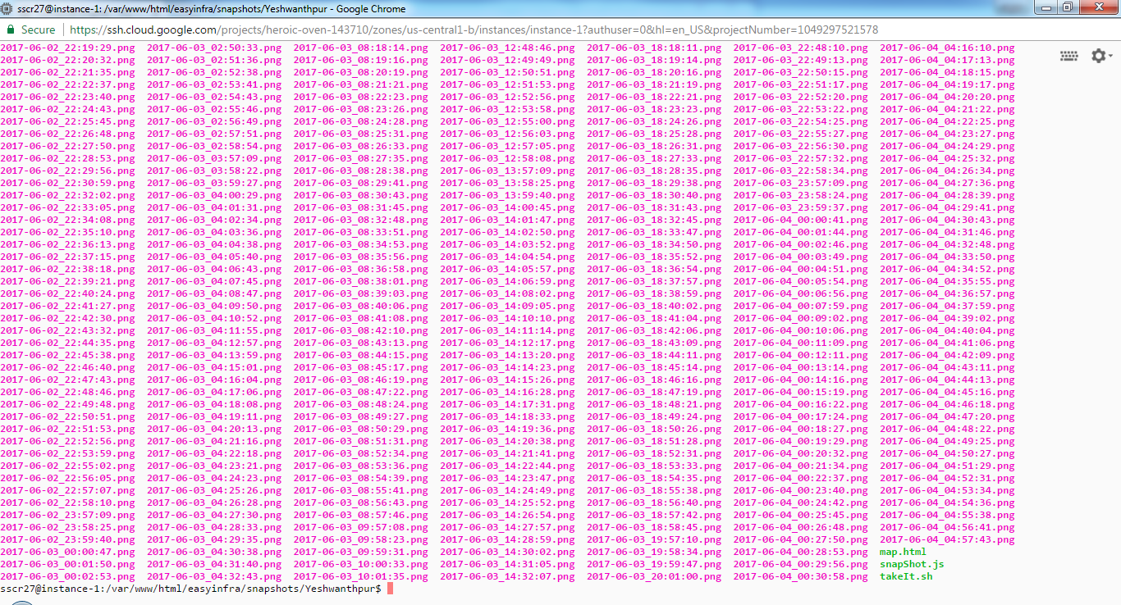

Figure 7.7 Storing Images for Processing

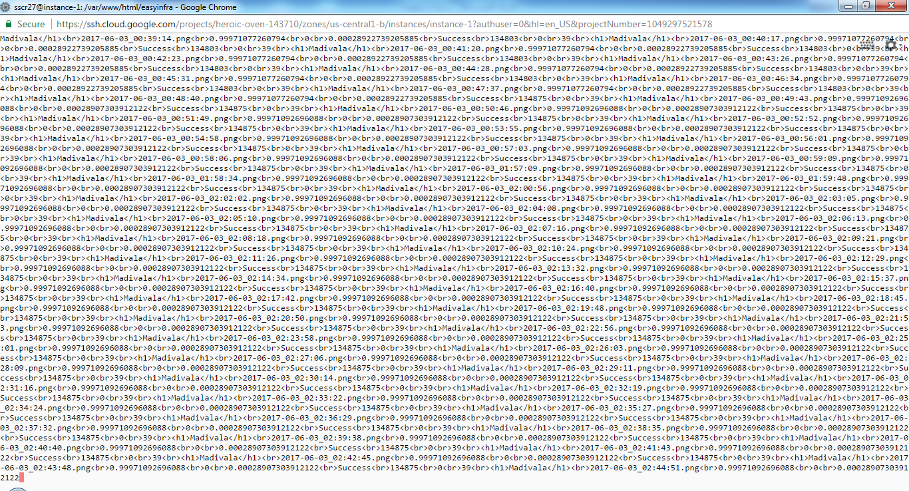

Figure 7.8 Computing Values for the Images Captured

**7.4 Hosting**

We chose hostinger.in for hosting our project. Hostinger provides free account with data storage upto 2000MB, two databases and two sub domains.

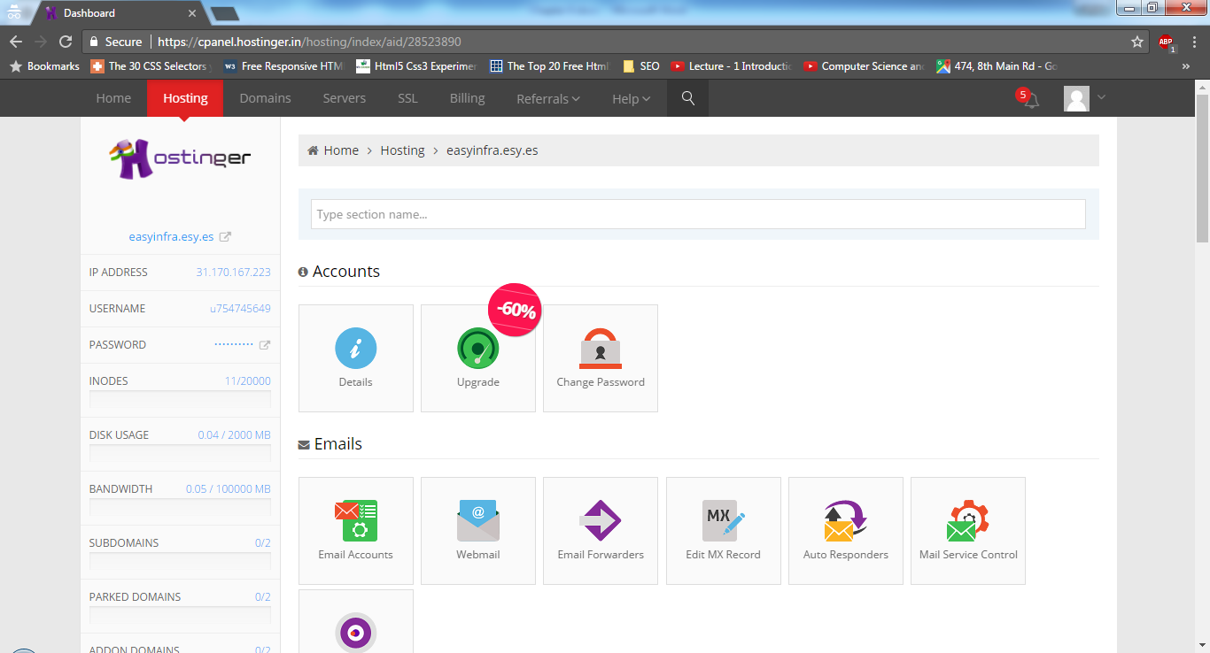

Figure 7.9 Hosting Account

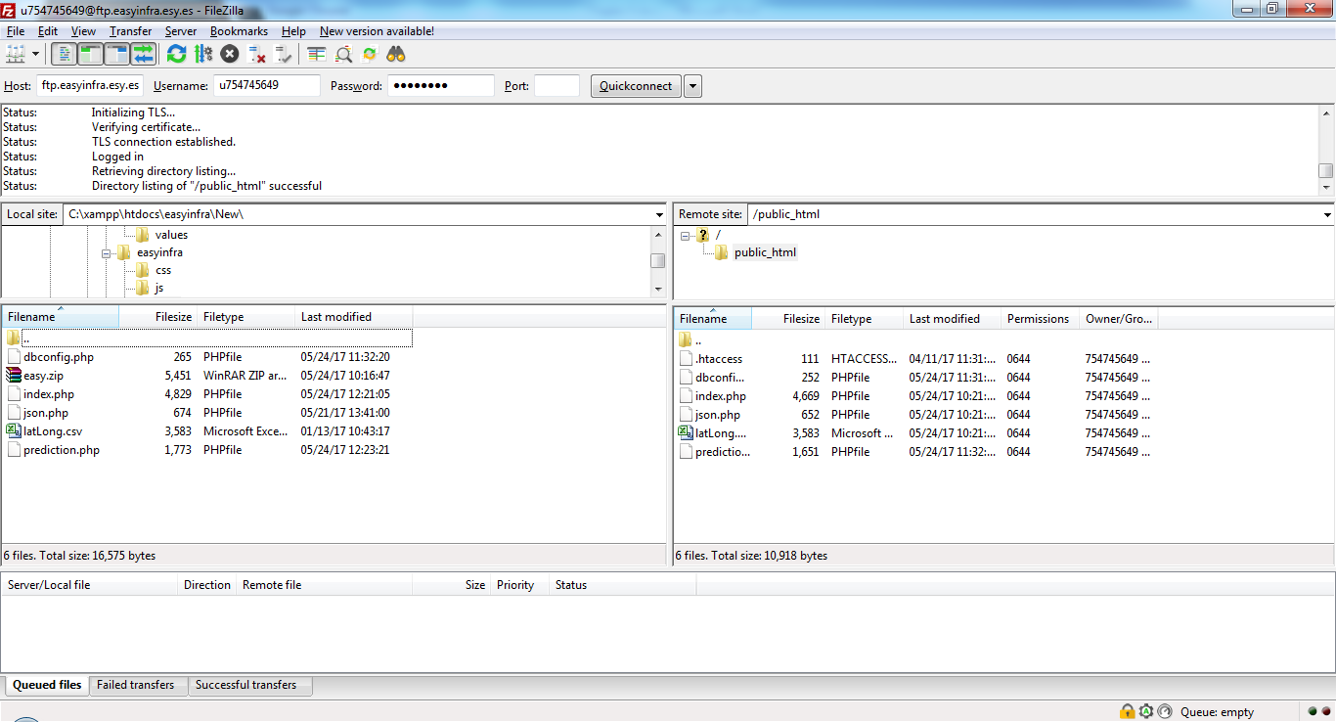

Figure 7.10 Connecting to EasyInfra Server

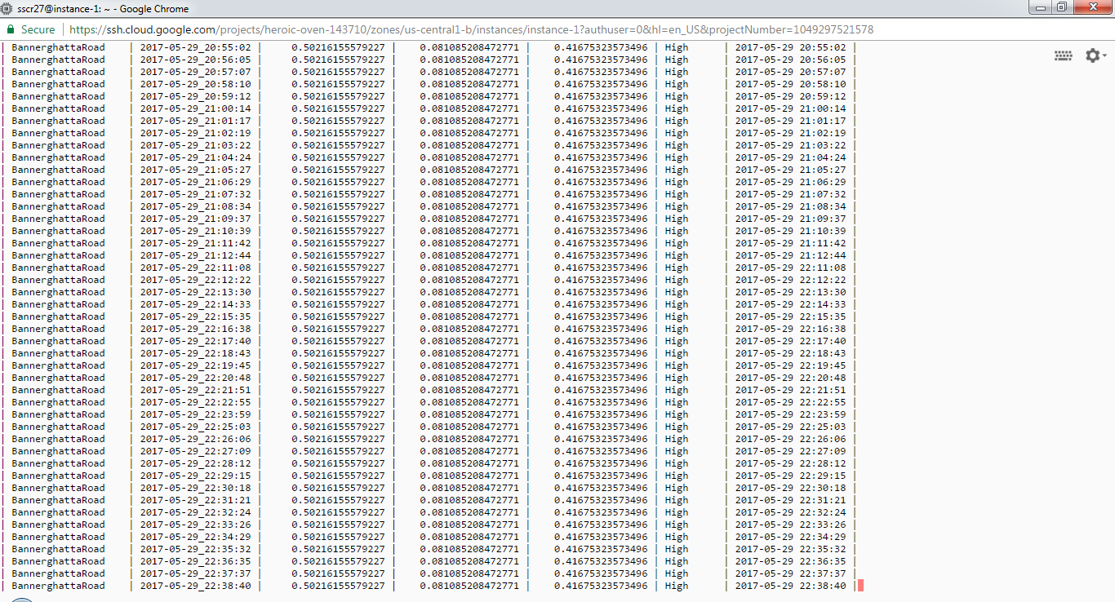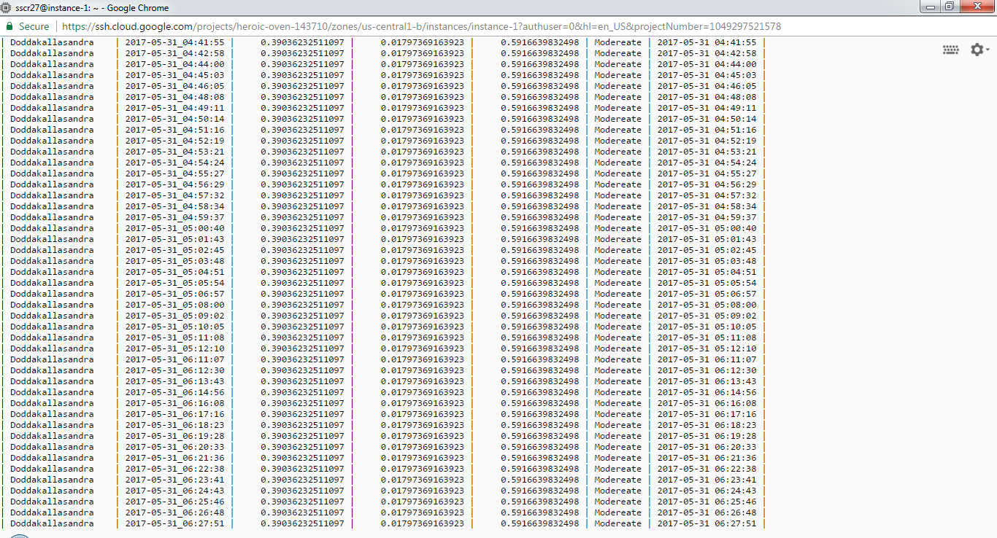

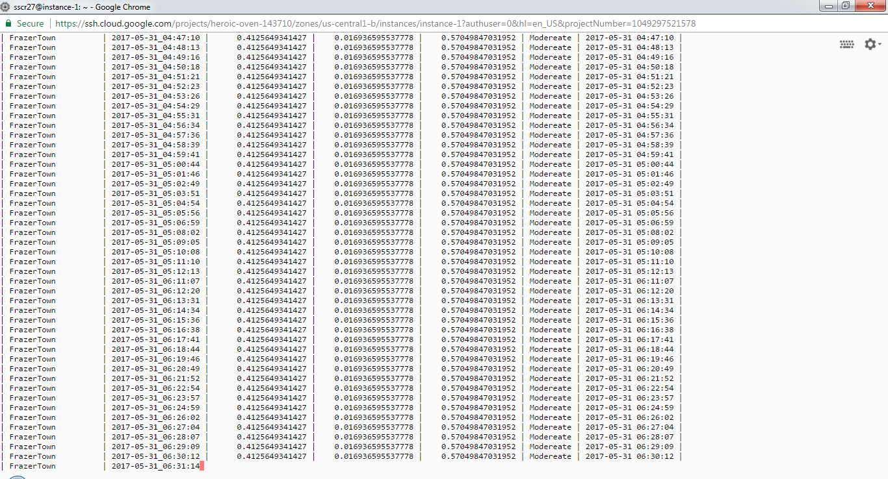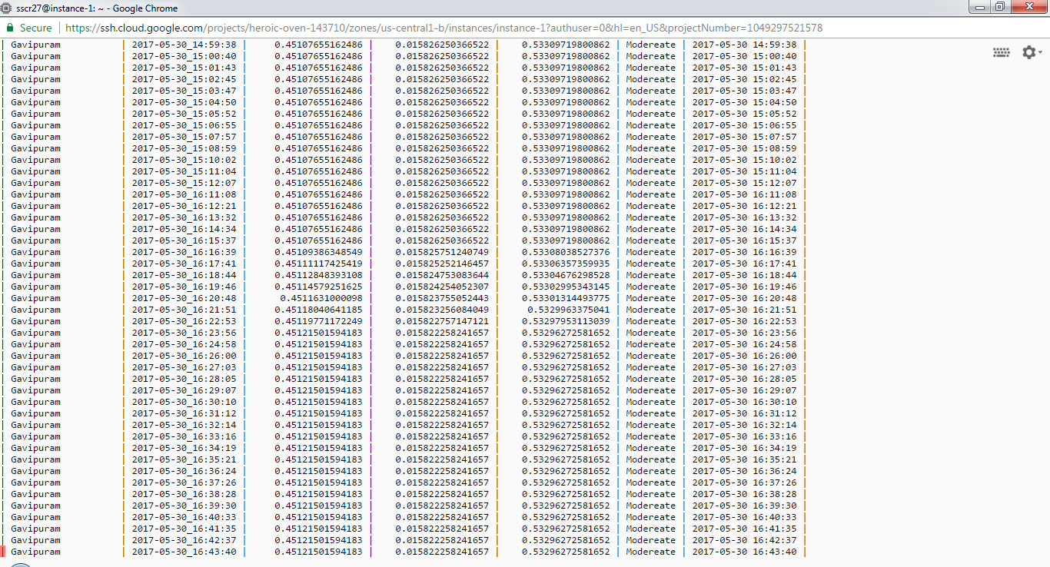

Figure 7.11 Storing values in Database

**7.5 Summary**

This chapter talks about the analysis made to show the prediction made and its reliability provided to the user.

**Chapter 8**

**RESULT**

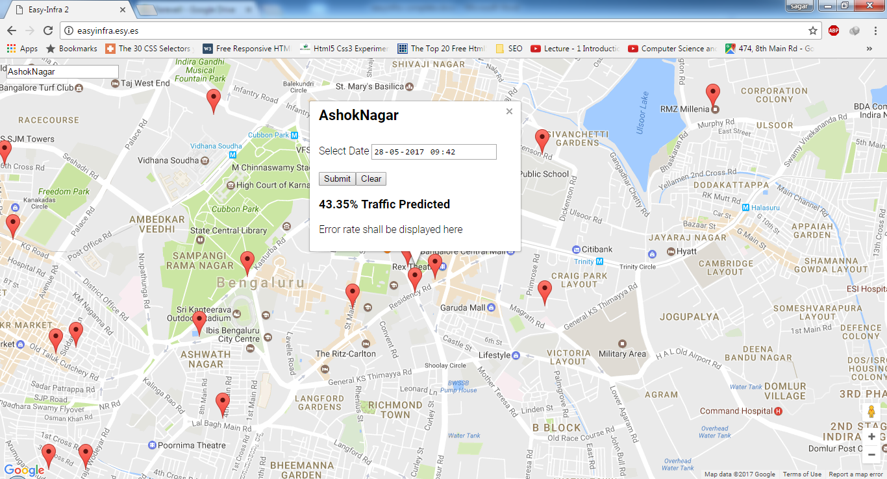

Figure 8.1 Predicted Traffic at AshokNagar

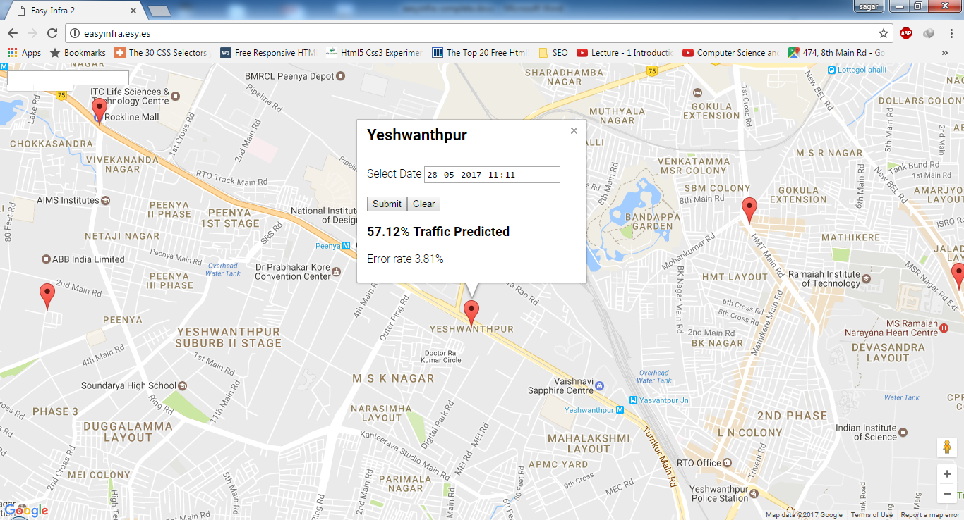

Figure 8.2 Analysed and Predicted Traffic at Yeshwanthpur

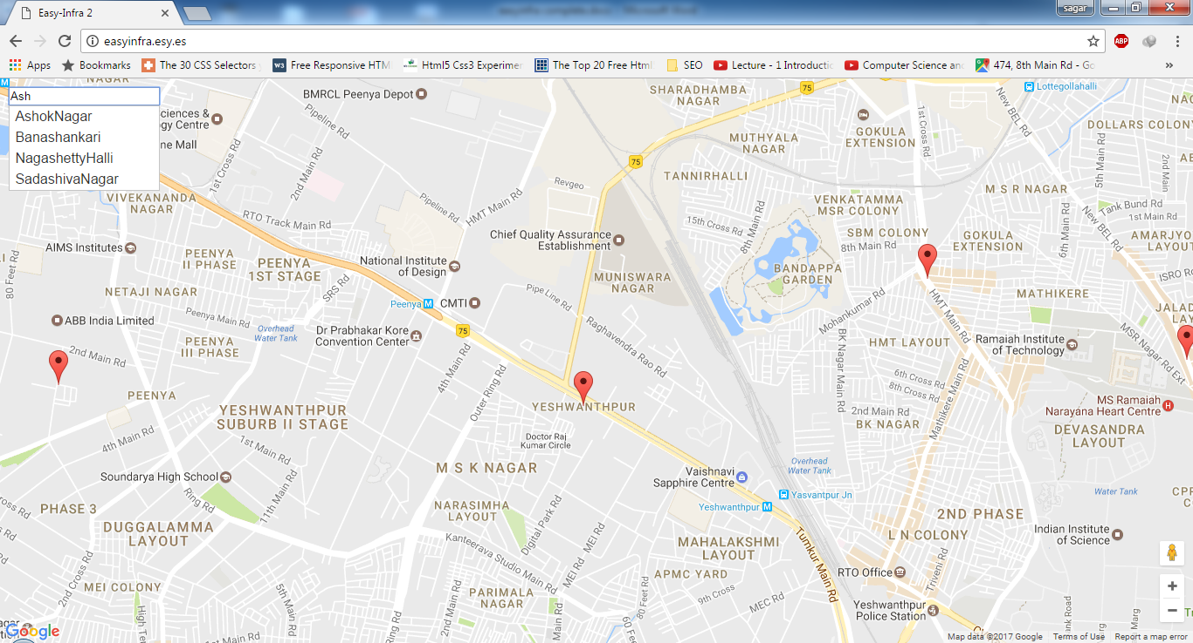

Figure 8.3 AutoComplete and Moving to that Location

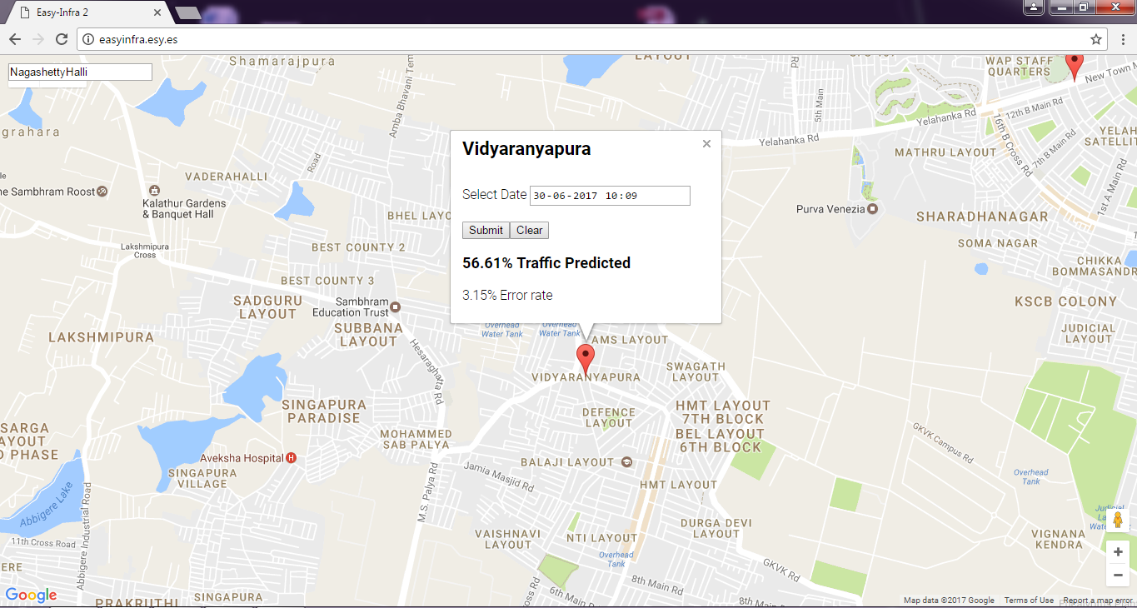

Figure 8.4 Analysed and Predicted Traffic at vidyaranyapura

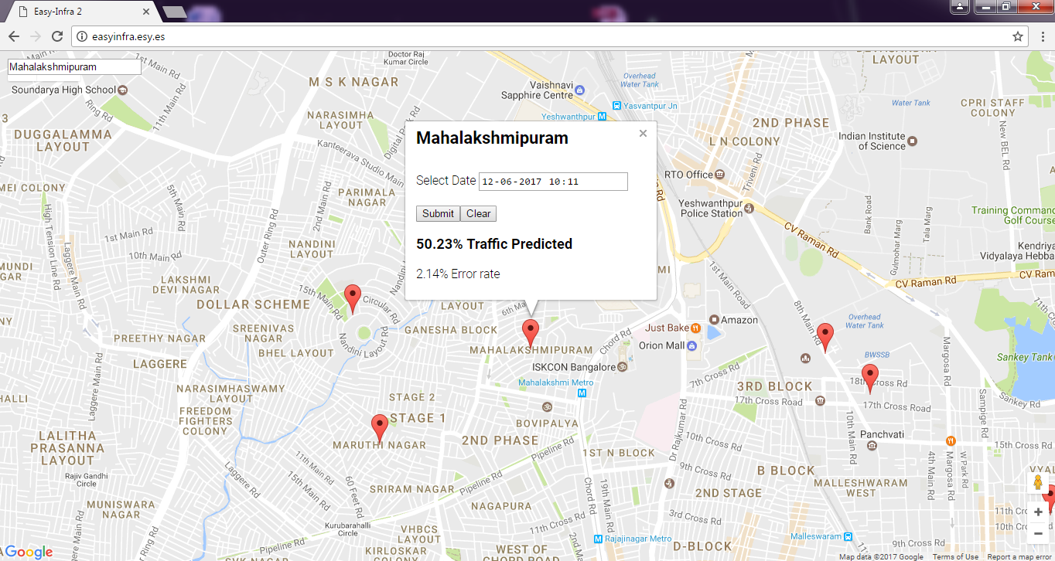

Figure 8.5 Analysed and Predicted Traffic at Mahalakshmipuram

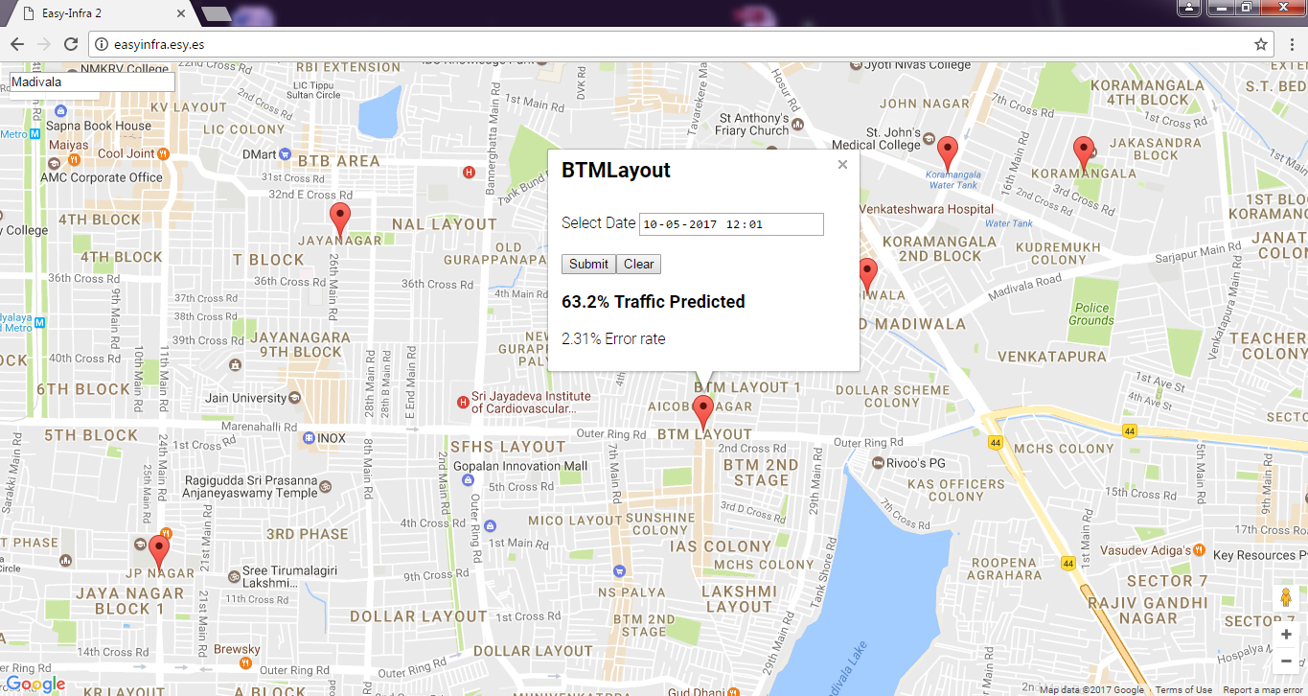

Figure 8.6 Analysed and Predicted Traffic at BTM layout

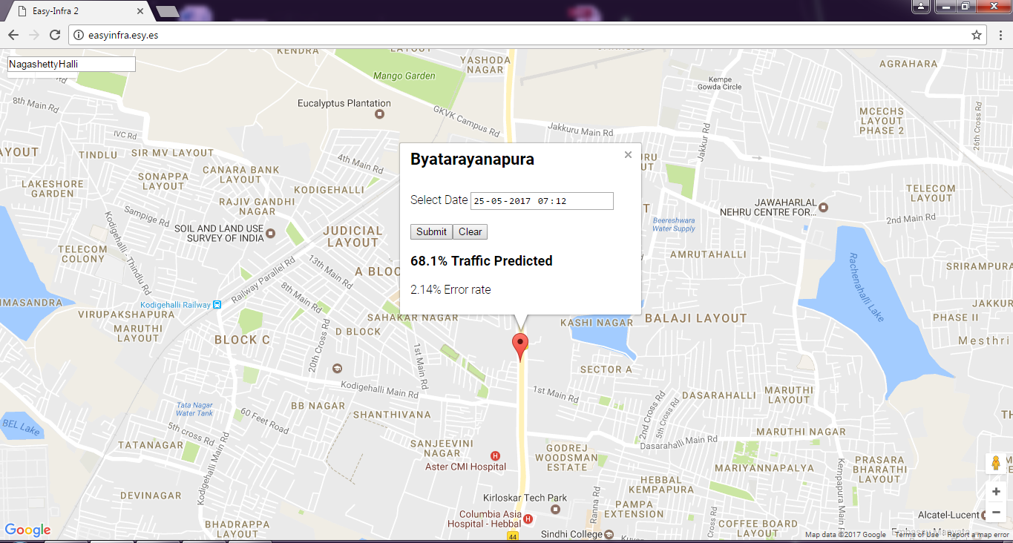

Figure 8.7 Analysed and Predicted Traffic at Byatarayanapura

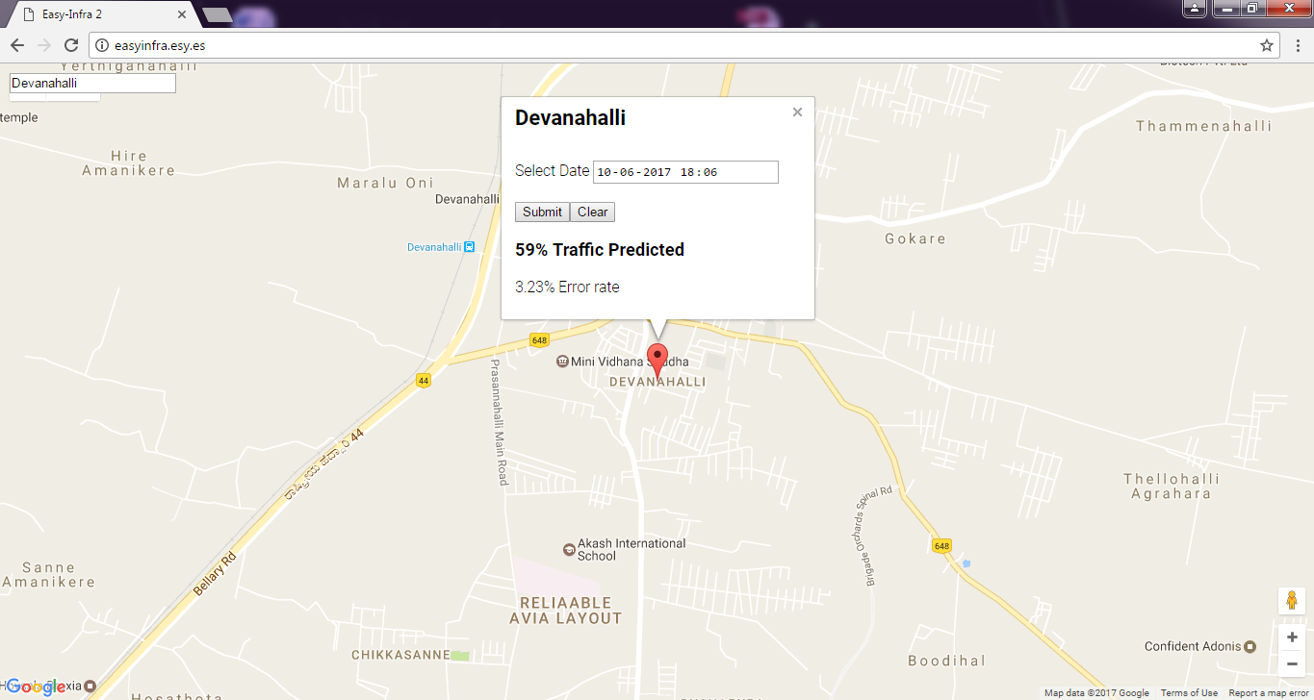

Figure 8.8 Analysed and Predicted Traffic at Devanahalli

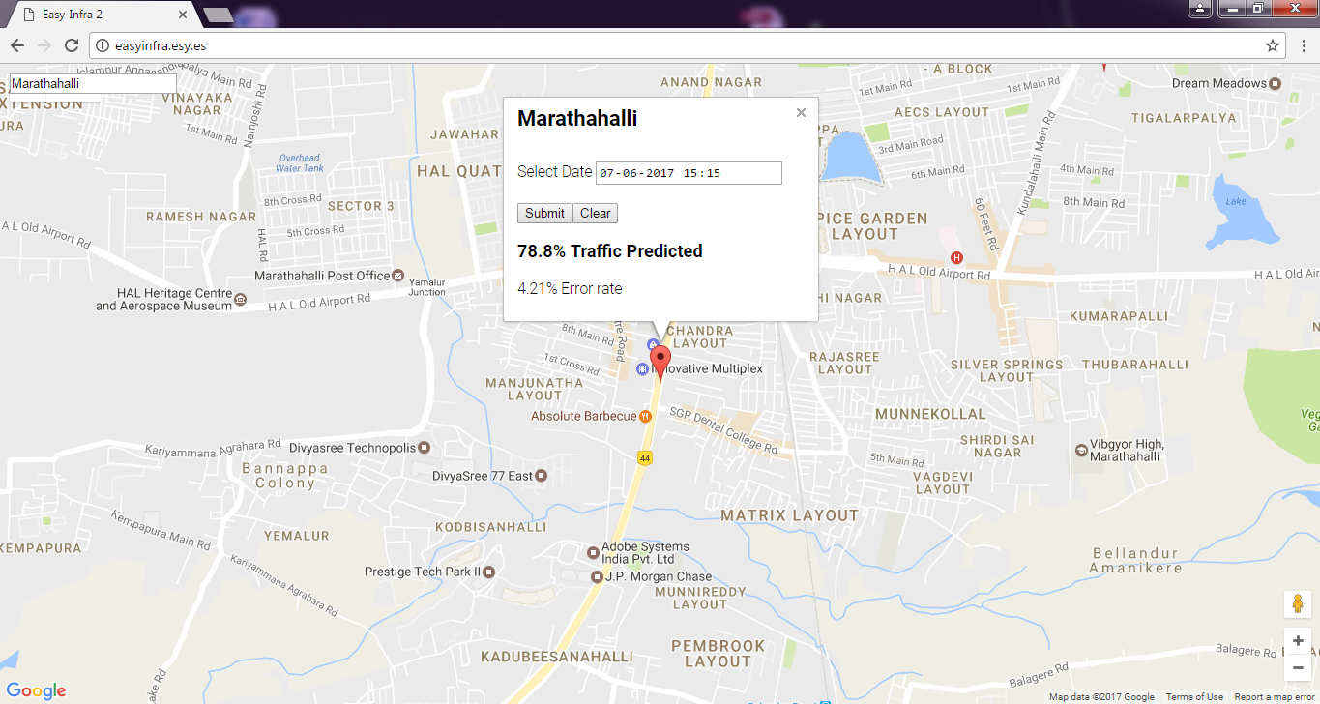

Figure 8.9 Analysed and Predicted Traffic at Marathahalli

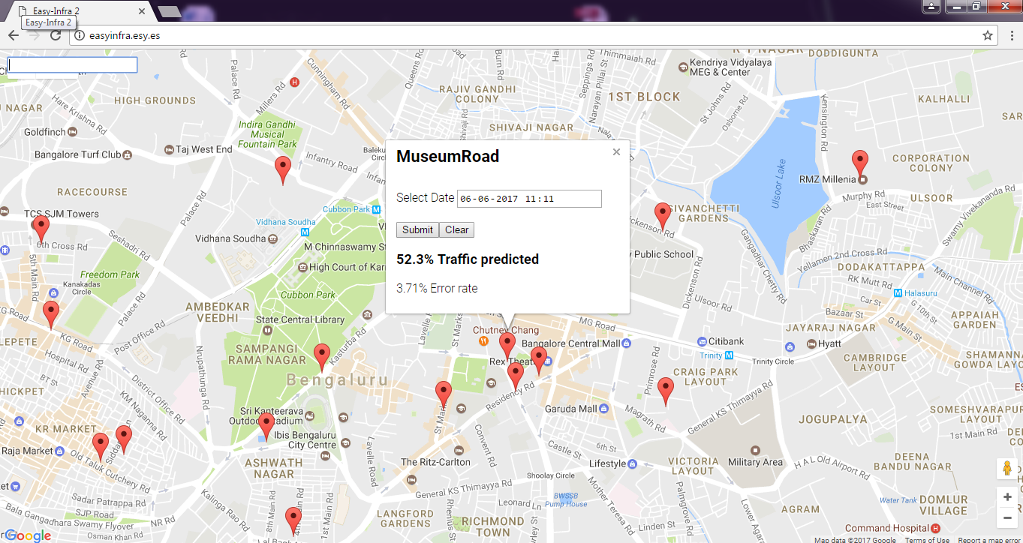

Figure 8.10 Analysed and Predicted Traffic at Museum Road

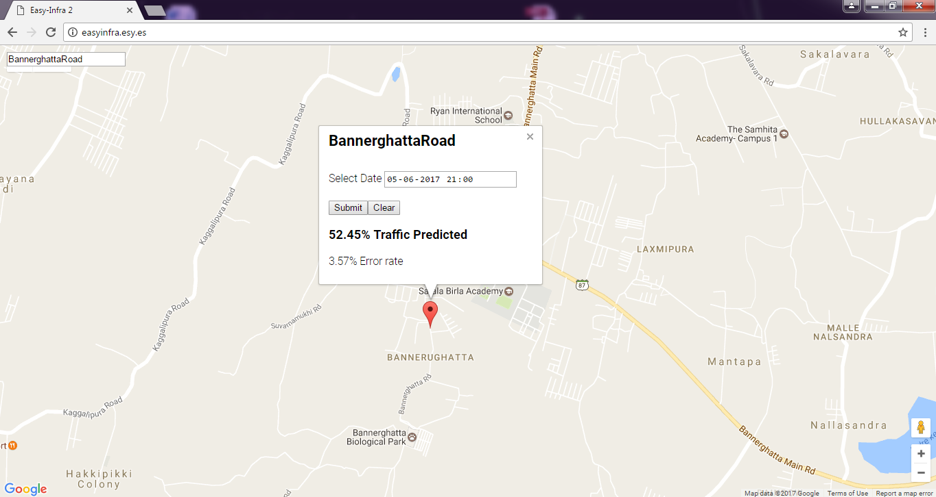

Figure 8.11 Analysed and Predicted Traffic at Bannerghatta road

**Chapter 9**

**CONCLUSION & FUTURE WORK**

Traffic estimation and prediction systems have the potential to improve traffic conditions and reduce travel delays by facilitating better utilization of available capacity. The success of ITS technology deployments is heavily dependent on the availability of timely and accurate estimates of prevailing and emerging traffic conditions. As such, there is a strong need for a “traffic prediction system”. This application not just helps the common people to know the future traffic conditions to find the alternative routes to the destination but has its application in many different ways. One of the main application and the future work of the this project is to develop a comprehensive tool that is being designed to predict an alternative path to the user so that they can reach the destination faster. This tool would be able to forecast, plan, and design considering all the parameters and at hand dynamically change the designs as per requirement in matter of minutes. This will not only facilitate the engineers with the survey but also will provide templates for design scientifically to help reduce the traffic congestion in the city.

**REFERENCES**

[1] http://www.badroadsinindia.com

[2] https://en.wikipedia.org/wiki/Indian_road_network

[3] http://qz.com/280082/the-true-cost-of-bangalores-traffic-gridlock-to-indias-it-industry-is-staggering

[4] http://www.forbes.com/2006/12/19/india-most-congested-cities-biz-energy cx_rm_1219congested.html

[5] http://indiatransportportal.com/increasing-number-of-cars-on-indian-roads-9465

[6] http://www.theiet.org

[7] Plastic waste: It's use in construction of roads by Kurmadasu chandramouli, Allipilli satyaveni, Mallampalli.Ch.G.Subash

[8] http://www.caliper.com/tcovu.htm

[9] Performance Evaluation of Intelligent Adaptive Traffic Control Systems by Saeed Samadi , Ali Pajoumand Rad , Farhad Mohammad Kazemi , Hamed Jafarian .

[10] An Intelligent Secure Traffic Management System Based On Vanet by Abinaya.E, Sekar.R.

[11] Priority based traffic lights controller using wireless sensor networks by Shruthi K R & Vinodha. K.

[12] http://www.theinfolist.com/php/HTMLGet.php?FindGo=phantomjs

[13] http://phantomjs.org/

[14] Itseez leads the development of the renowned computer vision library OpenCV. http://itseez.com

[15]  http://code.opencv.org/projects/opencv/wiki/ChangeLog

[16] About opencv http://opencv.org/about.html

[17] Official Ubuntu Documentation https://help.ubuntu.com/

[18] Hill, Benjamin Mako (8 July 2005). "Announcing Launch of ($10 m) Ubuntu Foundation"

[19] Byous, Jon (c. 1998). "Java technology:The early years".Sun Developer Network. Sun Microsystems

[20] "History of MySQL". MySQL 5.1 Reference Manual. MySQL AB.

[21] Callaghan, Mark (13 April 2010). [MySQL at Facebook](https://www.youtube.com/watch?v=Zofzid6xIZ4).YouTube(Google)

[22] https://developers.google.com/maps/

[23] http://www.junction.com/google-maps/

[24] https://googleblog.blogspot.in/2011/10/step-inside-map-with-google-mapsgl.html

[25] http://directory.fsf.org/GNU/

[26] http://www.gnu.org/software/gsl/

[27] https://developers.google.com/chart/

[28] https://www.w3schools.com/php/

[29] https://en.wikipedia.org/wiki/Weka_(machine_learning)

[30] www.cs.waikato.ac.nz/ml/weka/

[31] https://cloud.google.com/storage/docs/faq

[32] https://cloud.google.com/getting-started/

[33] http://www.easyinfra.esy.es/